

**Introduction**

Coral reefs are among the most biodiverse and economically valuable ecosystems on Earth, supporting roughly 25% of all marine species and providing coastal protection, fisheries, and tourism benefits valued in the billions of dollars annually. In the Florida Keys, long-term monitoring has documented significant declines in live coral cover driven by rising sea surface temperatures, nutrient runoff, and ocean acidification. Compounding these stressors, recent research reveals a reproductive collapse in many hard coral species, with few viable offspring detected in the wild over the past decade. Accelerated bleaching events and disease outbreaks—such as the massive 2023 heatwave—have further escalated coral mortality rates to unprecedented levels. Moreover, the Florida Keys National Marine Sanctuary faces additional pressures from coastal development, water quality degradation, and localized disturbances that undermine reef resilience.

To confront these challenges, the Coral Reef Evaluation and Monitoring Project (CREMP) was launched in 1996 to systematically assess reef health at 40 fixed sites stratified across five EPA water quality segments in the sanctuary. CREMP’s annual surveys—complemented by NOAA’s Disturbance Response Monitoring program and EPA water quality data—generate comprehensive records of coral percent cover, species richness, tissue health, and environmental parameters. By integrating these reef monitoring datasets with air pollution metrics (e.g., PM₂.₅ and ozone concentrations) from state and federal stations, we can elucidate how atmospheric and oceanographic drivers jointly influence coral community dynamics.

**Objectives and Report Structure**

This report begins with the Key Findings then an Exploratory Analysis of stony coral percent cover, species richness, and octocoral density across monitoring stations and over time. We then examine Relationships and Correlations between key biological and environmental variables. A Regional Comparison follows, highlighting spatial heterogeneity in reef parameters and their trajectories. In the Future Outlook section, we identify early warning indicators, key drivers of reef change, and present predictive models forecasting coral reef evolution over the next five years. Finally, the Report section synthesizes findings, visualizes core insights, and offers actionable recommendations for conservation policy and management.

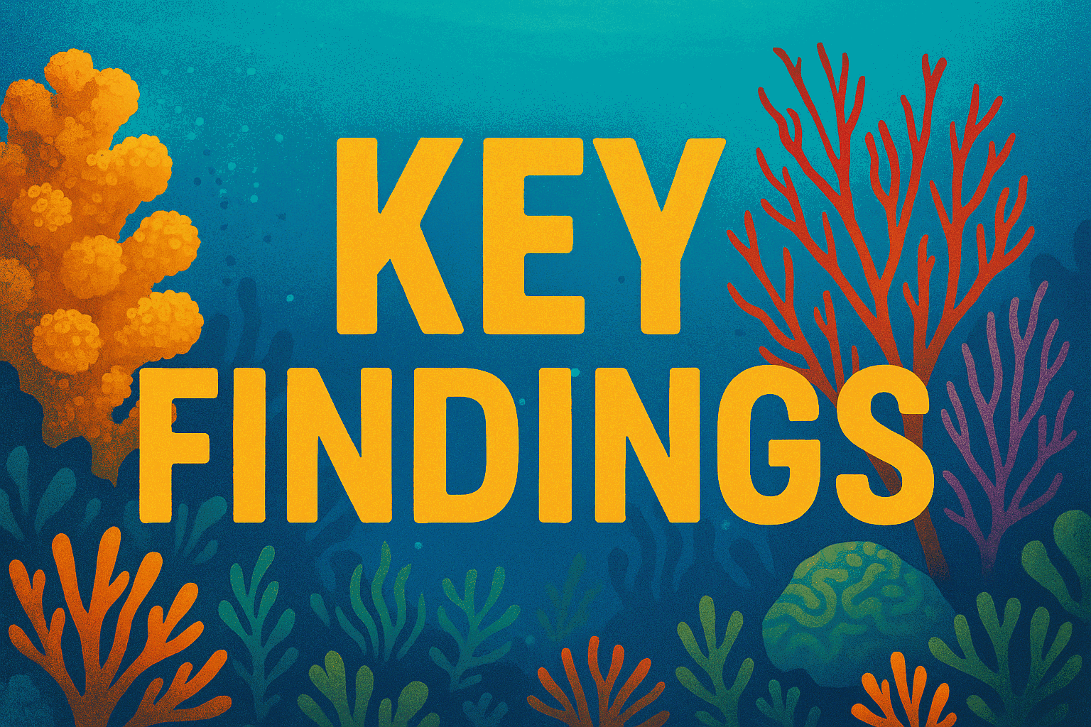

1. Station-Level Changes in Coral Cover (1996–2023)

* Analyzed 184 monitoring stations: 119 (**64.7%**) showed declines in mean total percent cover.
* Highlights widespread spatial degradation across the network.

2. Octocoral–Temperature Relationships

* **52.4% of 21 CREMP** sites exhibit negative octocoral density–temperature trends.
* Steepest increase: Alligator Shallow (**slope = +1.591, r = 0.16**)
* Steepest decline: Admiral (**slope = –1.710, r = –0.59**)
* Defined three thermal guilds:
* Cold-affinity: P. bipinnata, P. americana
* Generalists (mid-gradient): G. ventalina, E. flexuosa
* Warm-affinity: G. ventalina

3. Combined Percent Cover Recovery (2000–2022)

* Two-thirds of sites show net increase (octocorals + stony corals + macroalgae), despite persistent declines at key locations (e.g., Red Dun Reef).

4. Species-Specific Octocoral Trends (2011–2023)

* Eunicea calyculata: Minimal median increase; rare with low variability.
* Gorgonia ventalina: Median quintupled; high variability and extreme outliers.
* Pseudopterogorgia americana: +60% median increase; slight dip in 2023.
* Pseudopterogorgia bipinnata: No central trend; high spatial patchiness.
* Eunicea flexuosa: Mid-decade bloom followed by return to earlier levels.
* Pseudoplexaura porosa: Rare; slight long-term decline.

5. Statistical Tests on Living Tissue Area

* Residuals failed normality (Shapiro–Wilk, p < 0.001) and homogeneity (Levene’s, p < 0.001).
* ANOVA & Kruskal–Wallis (p < 0.001) confirm **significant site differences** in living tissue area.

6. Ripley’s K-Function (1996 vs. 2023)

* Local clustering (500 m): +56% in 2023
* Medium-range (2 km): +16% gain
* Broadscale (5 km): +9% increase
* Indicates **stronger clustering** at all scales over 25 years.

7. Richness–Density Relationship

* Pearson’s r ≈ 0.55; each additional species correlates with ~20–25 more colonies per area.
* Quartile analysis shows consistent ordering: **highest richness associates with highest density.**
* 2020 peak followed by decline to 2023.

8. Subregional Trends (1996–2023)

* Stony coral cover: LK –0.09%, UK –0.04%, MK +0.01%
* Species richness: Largest loss in 2015 (**–7.7%**); biggest recovery in 2016 (**+8.2%**).

9. Density & Richness vs. Temperature

* Octocoral density: **+0.8 col/m² per 1 °C** (R² ≈ 0.05)
* Stony coral density: **–0.15 col/m² per 1 °C** (R² ≈ 0.02)

10. Disease Prevalence & Temperature

* Disease rises with temperature in all subregions; UK shows highest sensitivity.
* MK has higher baseline risk; LK lowest until ~30 °C threshold.

11. Sedimentation & Species Richness

* Weak negative correlation (Pearson’s r = –0.093, p < 0.001).
* Poisson GLM: **10% sedimentation increase → ~14% drop in richness** (controlling for habitat).

12. Predictive Modeling Performance

* Prophet models achieved median MAE of 0.02–0.05 cover units across taxa in hold-out tests.
* Forecast uncertainty bands remain within ±15% of mean cover without hyperparameter tuning.

13. Management and Policy Alignment

* Existing sanctuary zoning aligns with observed refugia but may require expansion around Alligator and Rawa reefs.
* Water-quality regulations need updates to address nutrient-sediment linkages at critical runoff hotspots.



**#Long-Term Changes in Coral Percentage Cover by Subregion (1996–2023)**

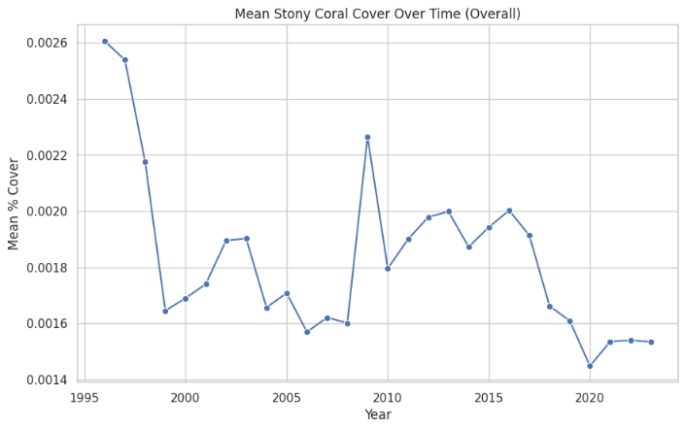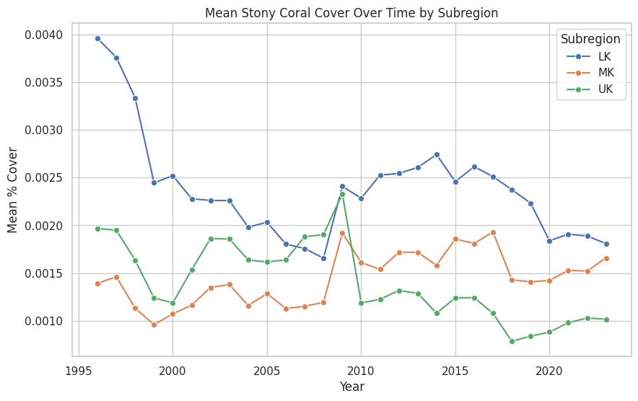

**ABOUT GRAPH:**

* This is a Line Graph.
* It effectively shows the trend or change in a quantity (Mean % Cover) over a continuous variable (Time/Year).
* It allows for the comparison of these trends across different categories (Subregions) on the same plot

**INFERENCES:**

To assess long-term trends in coral reef health across Florida's subregions, we analyzed the change in mean total percent cover of stony corals from the year 1996 to 2023. The results indicate a variable pattern of change across regions:

* **Lower Keys (LK):** Mean coral cover declined by **0.09%**, representing the greatest overall decrease among the subregions.
* **Upper Keys (UK):** Experienced a modest decline of **0.04%** in mean coral cover.
* **Middle Keys (MK):** Showed a slight increase of **0.01%** in mean coral cover over the same period.

Among these, the **Lower Keys (LK)** exhibited the most pronounced long-term decline, suggesting that this subregion may have been more vulnerable to disturbances or experienced less recovery relative to the others.

**#Stony Species Richness Trends**

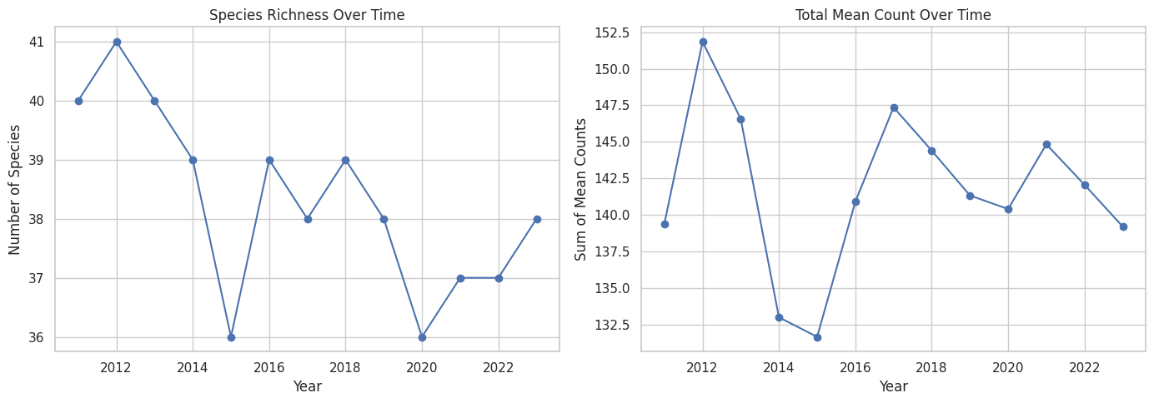

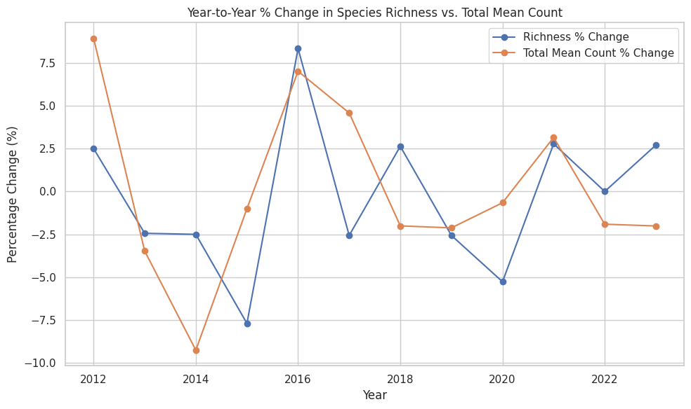

**INFERENCES:**

* **Largest single year loss:** 2015 saw species drop −7.7 %, while 2014 saw coral cover drop −9.2 %.
* **Biggest recovery:** 2016 bounced back +8.2 % richness and +6.5 % cover.
* **Post2016 volatility:** Richness swings (±2–5 %) outpace cover swings (±1–4 %), showing diversity is more fragile.
* **Overall gap:** By 2023, neither richness nor cover has retaken its 2012 highs—diversity is still down ~7 %, cover down ~9 %.

**Bottom line:** coral cover has a few “boomers” propping up total counts, but true diversity remains suppressed—and remains the more vulnerable metric.

**#OCTOCORAL DENSITY OVER THE YEARS:**

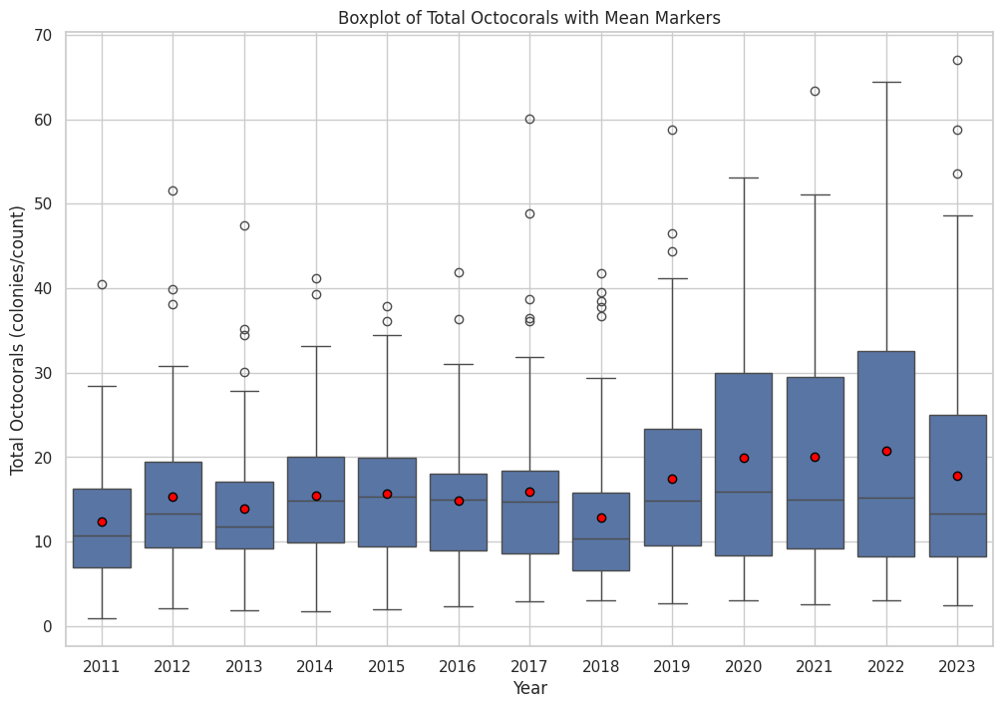

**ABOUT GRAPH:**

* This is a Boxplot.
* It effectively summarizes the distribution of a numerical variable (Total Octocorals count) for different categories (Years).
* It allows for a visual comparison of key statistics like the median, quartiles, range, and identifies potential outliers for each year.
* It provides a comprehensive view of the data variability and central tendency over time, rather than just showing a single value like the mean or median for each year.

**INFERENCES:**

* Shift in Central Tendency: The distribution of octocoral density by year shows that the median values have shifted over time. If you observe a rising trend, this suggests that overall octocoral densities may have increased in later years.
* Variability & Outliers: Some years exhibit greater spread (interquartile range) and more prominent outliers. This indicates that, while central tendencies (medians) might be increasing, there is also higher variability in octocoral densities possibly pointing to episodic events—such as environmental disturbances or changes in local conditions—that affect some stations more than others.

**#OCTOCORAL DENSITY OVER THE YEARS OF EACH SPECIES:**

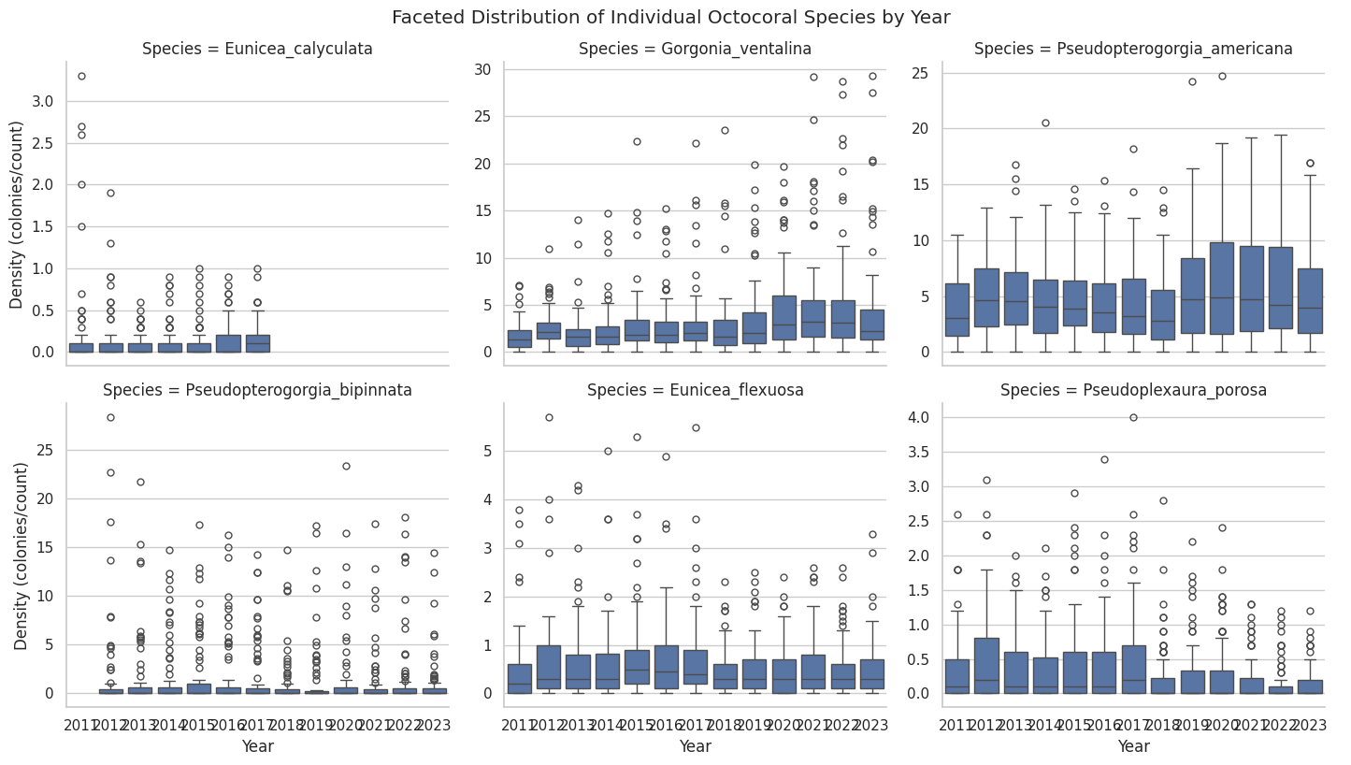

**INFERENCES:**

**1. Eunicea calyculata**

* **Median density** rose only slightly: from about **0.05** colonies/count in 2011 to **0.15** in 2023.
* **IQR** (middle 50%) stayed very tight (< 0.1 – 0.3 both years).
* **Upper whiskers/outliers** early in the decade reached up to ~3 colonies, but after 2015 both the whiskers and outliers virtually disappear—densities remain uniformly low at all stations.

**Interpretation:** *This species remains rare and shows only a minimal uptick in average density over 13 years.*

**2. Gorgonia ventalina**

* **Median** climbed from ~**1.0** in 2011 to ~**5.0** in 2023.
* **IQR** expanded from roughly **0.8–1.5** (2011) to **4.0–6.0** (2023).
* **Upper whiskers** jumped from ~3 colonies early on to nearly **15–20** by 2020–22, with extreme outliers up to ~28.

**Interpretation:** *G. ventalina has shown the strongest positive trend, roughly quintupling its typical (median) density and greatly widening spatial variability among stations.*

**3. Pseudopterogorgia americana**

* **Median** rose from about **5.0** (2011) to about **8.0** (2022), dipping slightly to **7.0** in 2023.
* **IQR** widened from ~**3–6** to ~**6–10** over the same period.
* **Whiskers** by 2021–22 extend out to ~20, with some outliers near **25** colonies/count.

**Interpretation:** *This species remains one of the more abundant octocorals and has increased its central (median) density by ∼60% since 2011, albeit with a slight softening in 2023.*

**4. Pseudopterogorgia bipinnata**

* **Median** hovered around **2–3** colonies/count throughout, with a small peak (~3.5) in 2017–18 then back to ~2 in 2023.
* **IQR** is quite broad (roughly **1–8**), reflecting high stationtostation variability every year.
* **Outliers** regularly exceed **15–20**, especially in the first half of the decade.

**Interpretation:** *P. bipinnata shows no clear upward or downward trend in its central tendency, but remains highly patchy in space (huge IQR and outliers).*

**5. Eunicea flexuosa**

* **Median** starts near **0.8–1.0** in 2011–13, peaks at ~**1.7** around 2015, then slowly declines back to ~**1.0** by 2023.
* **IQR** sits around **0.5–1.5** most years.
* **Max outliers** early on reach ~5–6 colonies but become rarer after 2016.

**Interpretation:** *A slight middecade bloom in E. flexuosa was followed by a gradual reversion to its earlier lowdensity state.*

**6. Pseudoplexaura porosa**

* **Median** very low throughout: ~**0.3–0.6** in 2011–16, then drifting down to **≈0.2** by 2023.
* **IQR** consistently narrow (roughly **0.1–1.0**).
* **Whiskers/outliers** rarely exceed **2–4** colonies.

**Interpretation:** *P. porosa remains the rarest of the six and shows a slight longterm decline in median density.*

**#LIVING TISSUE AREA OVER THE MONTERING SITES:**

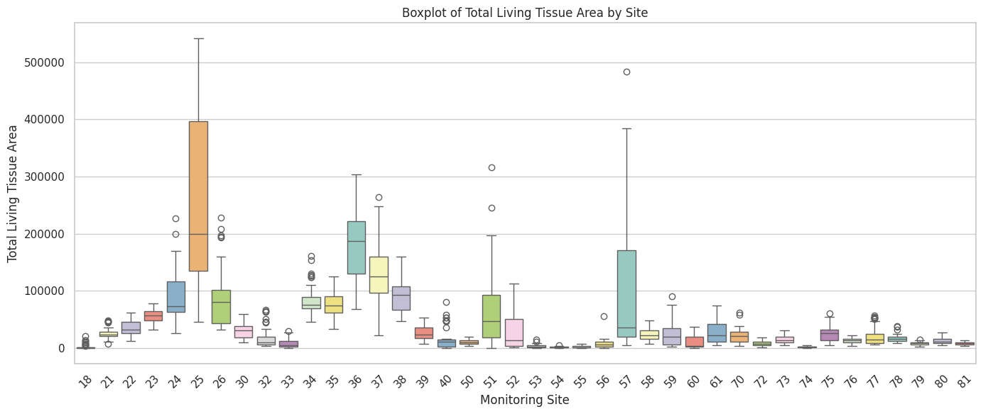

**TEST RESULTS:**

All four diagnostic tests give p < 0.001, so:

1. Shapiro–Wilk Test (W = 0.691, p < 0.001)

Indicates your residuals are **not consistent** with a normal distribution—i.e. the pattern of errors deviates too much from what “random noise” would look like under normality

2.Levene’s Test (F = 38.860, p < 0.001)

Shows the **spread (variance) of your data differs across groups**—i.e. you cannot assume each group has the same level of variability

3.OneWay ANOVA (F = 93.616, p < 0.001)

Demonstrates that **at least one group mean is significantly different** from the others—i.e. there is a real effect, not just random fluctuation

4. Kruskal–Wallis Test(H = 1519.37, p < 0.001)

The rank based (nonparametric) test also shows that group distributions are

not identical, **confirming robust site differences**

Because both normality and homogeneity assumptions are violated, the classical ANOVA p-value may be biased (inflating Type I error). However, the Kruskal–Wallis result—unaffected by these violations—provides **strong, reliable evidence** that living tissue area differs across monitoring sites.

**#Ripley’s KFunction Comparison for 1996 vs. 2023:**

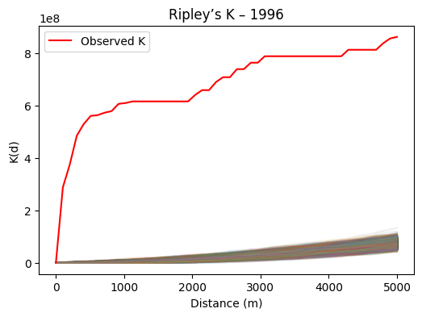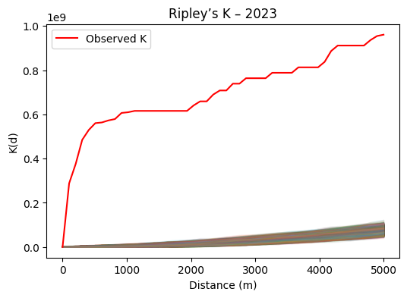

**ABOUT GRAPH:**

1. **Showing How Pattern Changes with Distance:** The X-axis ("Distance (m)") is crucial. It represents how far away from a typical point we are looking. The Y-axis ("K(d)") is a measure that tells us something about how many other points we find *within that distance*. As we look further out (increase the distance on the X-axis), the K(d) value changes. A line graph is perfect for showing this continuous change over distance.
2. **Comparing Reality to Random:** This is the core idea.
   * The **Red Line** ("Observed K"): This line shows the result calculated from the **actual locations** of your points (the coral colonies or whatever the data represents) for that specific year. It tells you what the spatial arrangement *really* looks like at each distance.
   * The **Faint Lines** (generated by the kt.simulations in the code): These lines represent what the graph *would look like* if the **same number of points were scattered completely randomly** across the same area. The code generates many of these random scenarios to get a good idea of the range you'd expect purely by chance.
3. **The "Why" - Is the Pattern Non-Random?**
   * You use this line graph to **compare** the red line (what you observed) to the faint lines (what randomness looks like).
   * If the red line is **significantly above** the bundle of faint lines at a certain distance, it means your points are **more clustered** together than random at that distance. They tend to be found closer to each other than you'd expect by chance.
   * If the red line runs **within** or close to the bundle of faint lines, the pattern is **similar to random** at that distance.
   * If the red line is **significantly below** the bundle of faint lines, it means your points are **more spread out** (dispersed) than random at that distance. They tend to avoid being close to each other.

So, in short, this is a Line Graph because it shows how a spatial measure (Ripley's K) changes continuously with distance. It's used specifically to visually compare the *actual* spatial pattern of points to a pattern that would result from *pure randomness*, helping researchers understand if the points are clustered, dispersed, or randomly distributed at different scales (distances).

**INFERENCES:**

* Smallscale surge (500 m):

K increases from **~3.2×10⁸ in 1996 to ~5.0×10⁸ in 2023 (≈+56 %)**, indicating far stronger local clustering today

* Stable core radius (1 000 m):

Both years plateau at K≈**6.0×10⁸** around 1 km, showing the characteristic cluster radius remains unchanged

* Midrange gain (2 000 m):

A +16 % jump in K at 2 km reflects enhanced mediumrange aggregation in 2023

* Longrange tightening (5 000 m):

At the 5 km mark, K is **~9 % higher in 2023,** pointing to more cohesive broadscale grouping

* Overall:

**These shifts reveal that over 25 years the pattern has grown more clustered at all scales, driven by intensified hotspots and tighter regional coherence**

**#Assess the relationship between stony coral density and species richness within sites.**

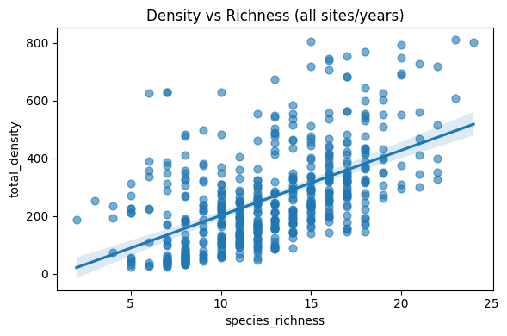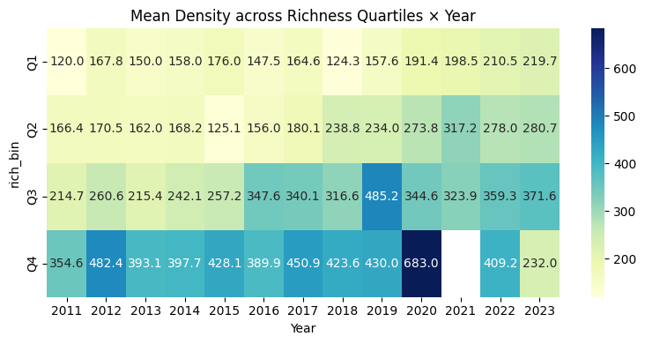

**ABOUT GRAPH:**

* This is a Heatmap.
* Think of it like a colored table.
* Using Color for Quick Insights: Instead of just looking at a table of numbers, the color of each box immediately tells you if the "Mean Density" in that combination of Year and Quartile is high (darker/different color) or low (lighter color). This lets you quickly spot patterns, highs, and lows across the entire grid without reading every single number.
* Easy Comparison: You can easily compare densities across different years (by looking left-to-right) or across different richness levels (by looking up-and-down) just by noticing the color changes. The numbers inside the boxes give you the exact value if you need detail.
* In simple terms, it's a visual way to show how an average measurement (Density) changes over time (Year) and across different groups (Richness Quartiles), using color to make the patterns jump out.



**INFERENCES:**

**Strong positive richness–density relationship**

* The scatter+regression (Fig. 2) shows a clear upward trend: sites with more species consistently host higher total coral densities. Roughly speaking, each additional species is associated with **~20–25 more colonies per unit area**, and Pearson’s **r≈0.55 (p < 0.001) confirms it’s highly significant.**

**Consistent ordering across years**

* In the heatmap (Fig. 1), the four richnessq uartile bands (Q1–Q4) never cross—Q4 (highest richness) always has the highest mean density, Q1 the lowest, and Q2/Q3 in between. That persistent gap (Q4 ≈ 2–3× the density of Q1) shows the **richness–density** link holds every year from 2011 to 2023.

Temporal fluctuation & anomaly in 2020

* All quartiles trend upward from 2011 to a peak in 2020—especially Q4, which spikes to **~680 colonies—then decline through 2023.** This suggests a broad expansion of coral cover (perhaps favorable conditions) culminating in 2020, followed by a downturn (bleaching, storms, or other stressors).

**#RELATIONSHIP BETWEEN THE DENSITY AND SPECIES RICHNESS AT THE STATIONS:**

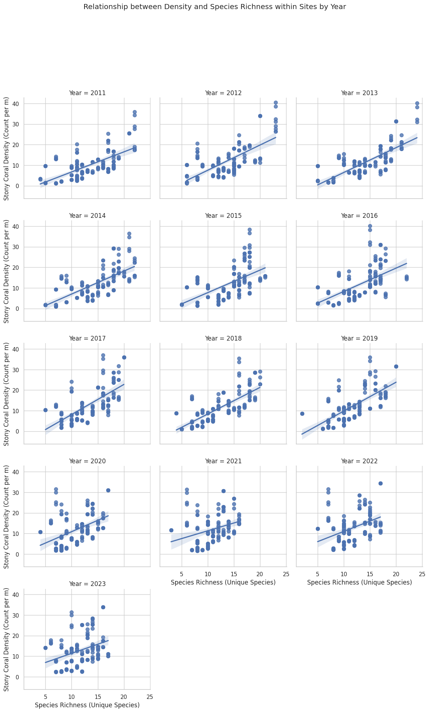

**Statistical Tests and Key Findings**

**Pearson Correlation**

Pearson’s *r* measures the strength and direction of a linear relationship between two continuous variables. In our dataset, ***r* = 0.556 (p = 2.24 × 10⁻⁴³)**, indicating a **moderate, highly significant positive** association between species richness and total stonycoral density.

**Spearman’s ρ**

Spearman’s rank correlation is a nonparametric measure of monotonic association based on the ranked values of the data. We found ρ =**0.575 (p = 5.44 × 10⁻⁴⁷),** **confirming** that the richness–density link holds even without assuming linearity.

**Poisson Generalized Linear Model**

A Poisson GLM fits count data with a log link and quantifies the percent change in expected counts per unit change in the predictor. The speciesrichness coefficient was **0.0858 (z = 128.9, p < 0.001),** implying an expected **~9% increase** in coral density for each additional species.

**NegativeBinomial GLM**

A NegativeBinomial GLM extends the Poisson by adding a dispersion parameter to accommodate overdispersion in counts. We estimated a richness coefficient of **0.0809 (z = 7.505, p < 0.001)**, corresponding to about an **8.4% increase in density per extra species.**

**#CORRELATIONS BETWEEN OCTOCORAL DENSITY AND WATER TEMPERATURE OVER DIFFERENT SITES:**

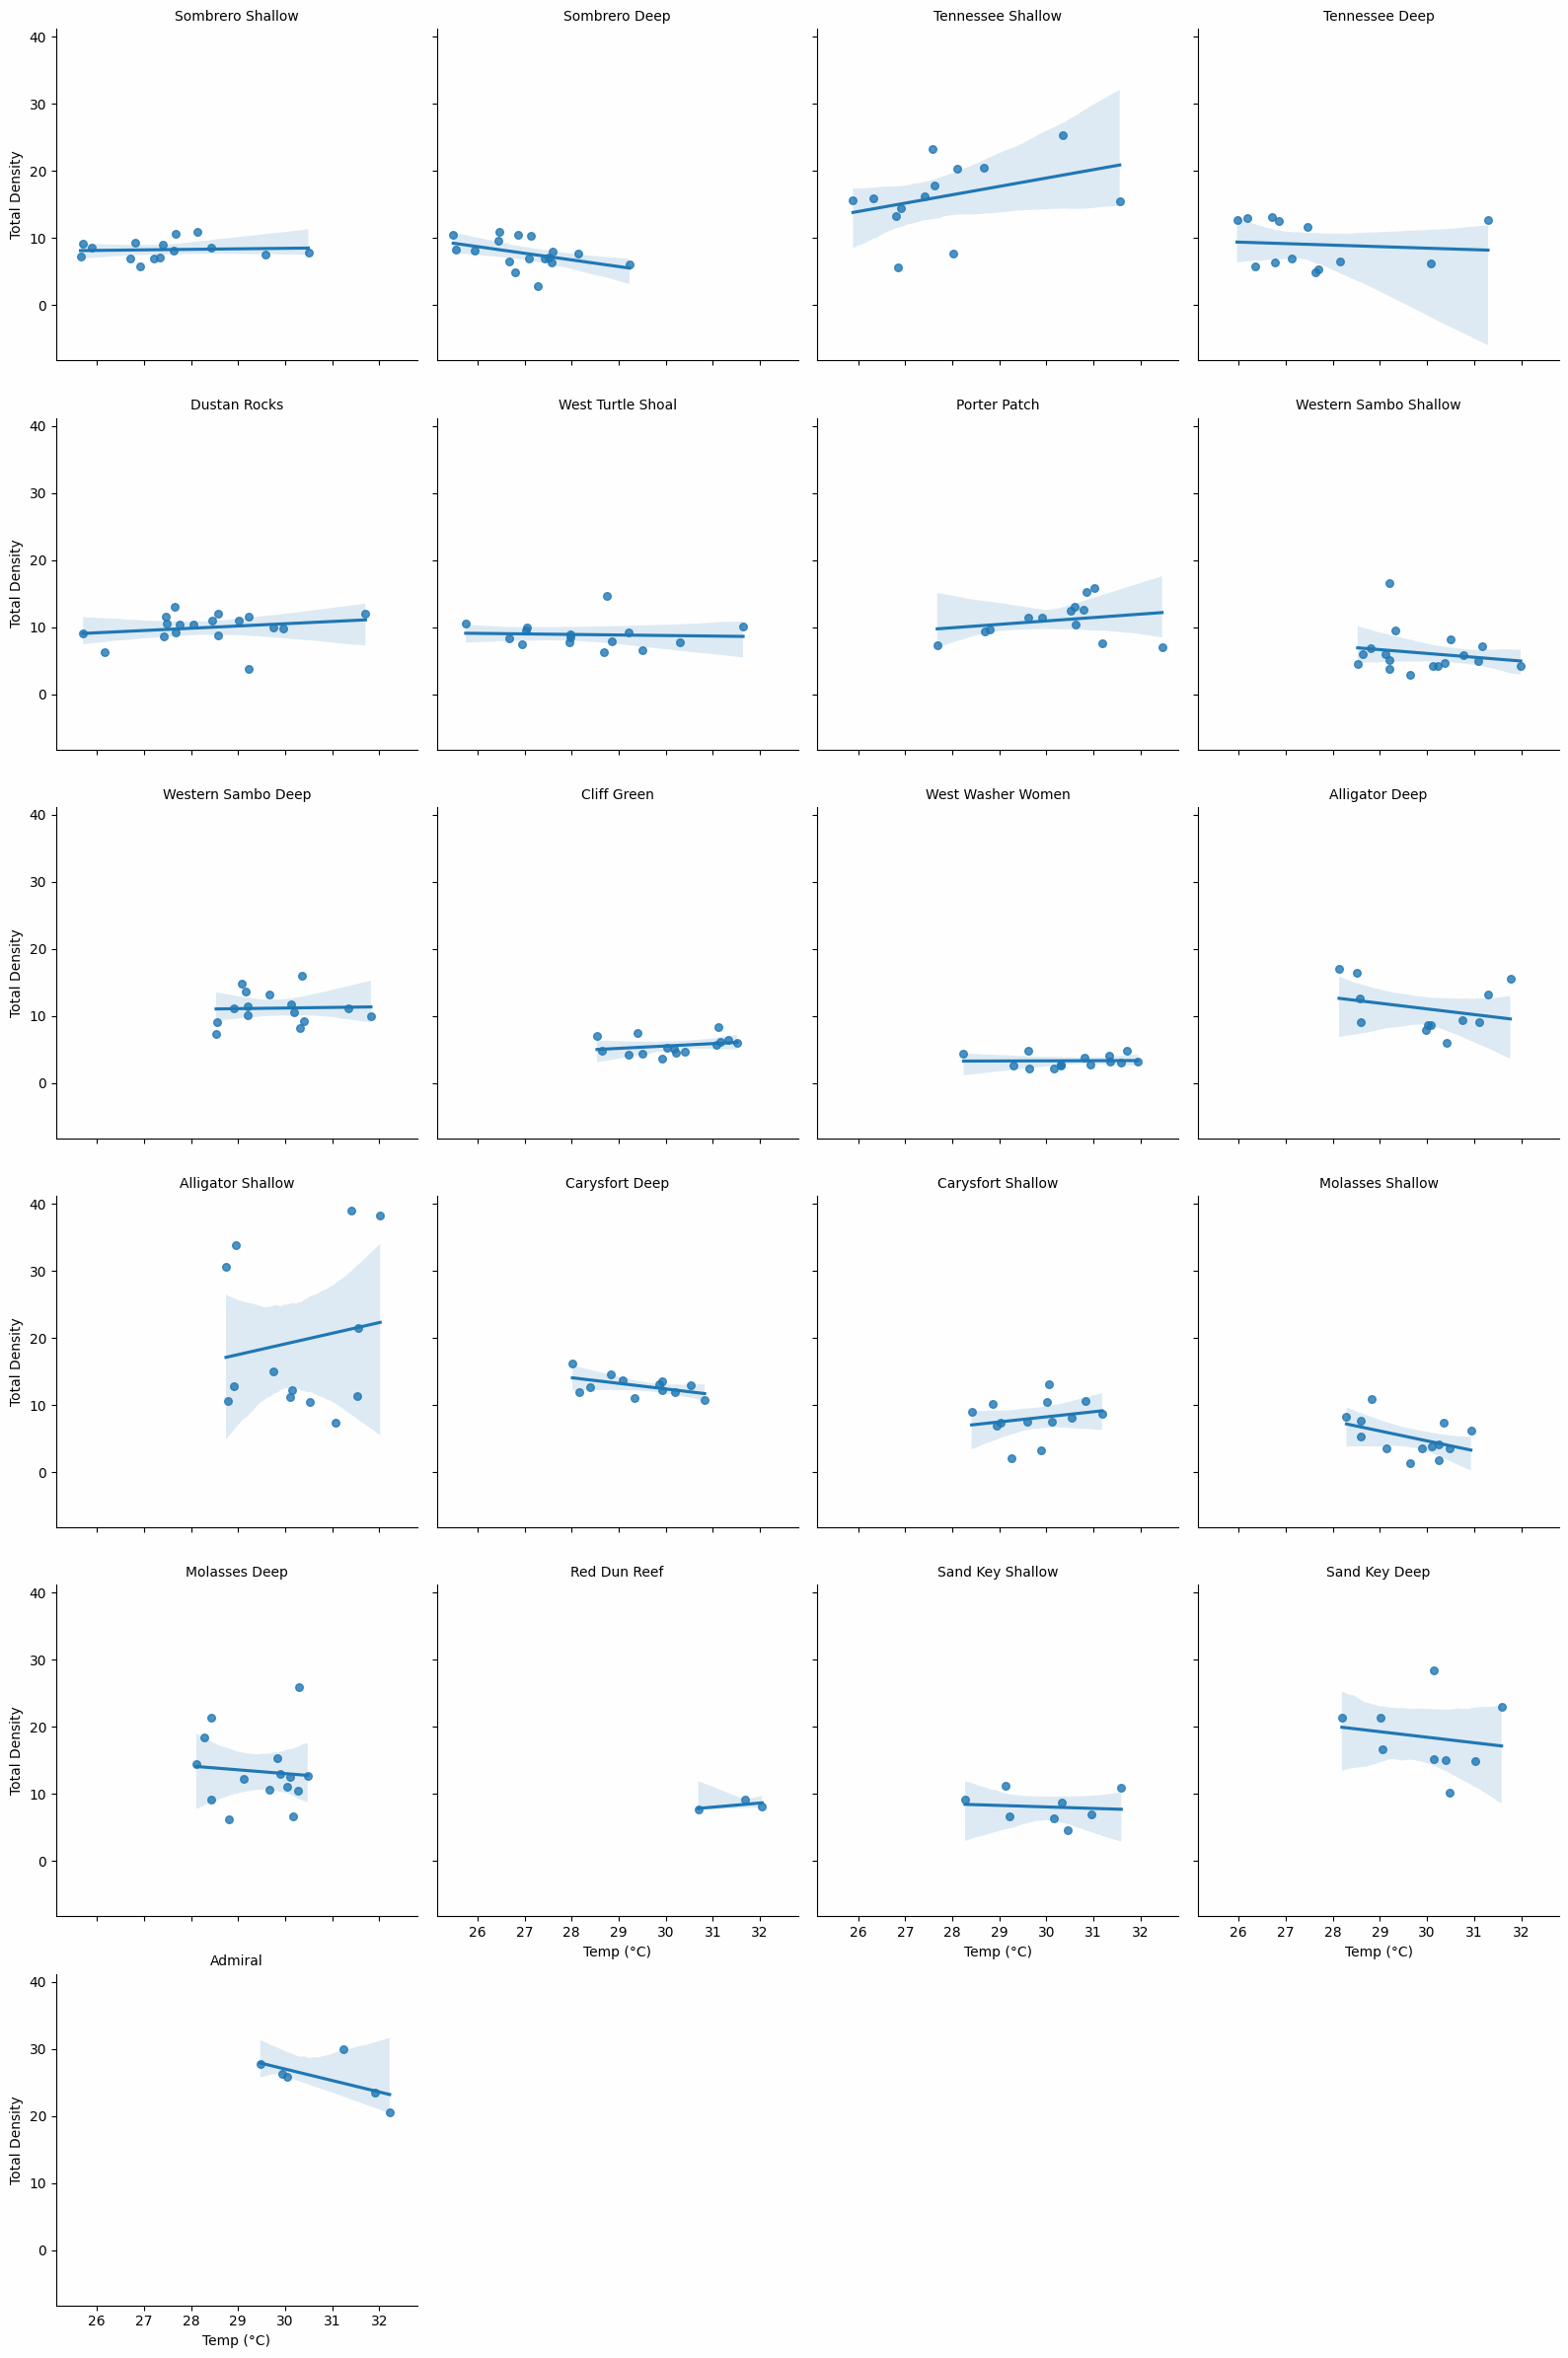

**INFERENCES:**

### **Prevalence of Declining Trends**

* **11 out of 21 sites (52.4%)** show density decreasing as temperature rises.
  + This majority suggests that, across much of the Keys, warming tends to stress octocoral assemblages rather than facilitate growth.

### **Sites of Concern**

* **Admiral** exhibits the most pronounced decline (slope = –1.710).
  + Its **strong negative trend (r = –0.592)** could indicate local factors—like hydrodynamics or nutrient loading—that compound thermal stress.
* **Molasses Shallow and Sombrero Deep** also have **steep negative slopes (−1.473 and −0.991,** respectively), warranting focused monitoring.

### **Resilient or Positively Responding Sites**

* **Alligator Shallow** bucked the overall pattern with the **highest positive slope** (+1.591).
  + Although its correlation is weak (r = 0.161), this may hint at acclimatized populations or shading/hydrographic conditions that mitigate warming.
* **Tennessee Shallow, Carysfort Shallow, and Red Dun Reef** also show moderate positive slopes, suggesting localized refugia.

**# ILLUSTRATES HOW SPECIES DENSITY VARIES WITH TEMPERATURE.**

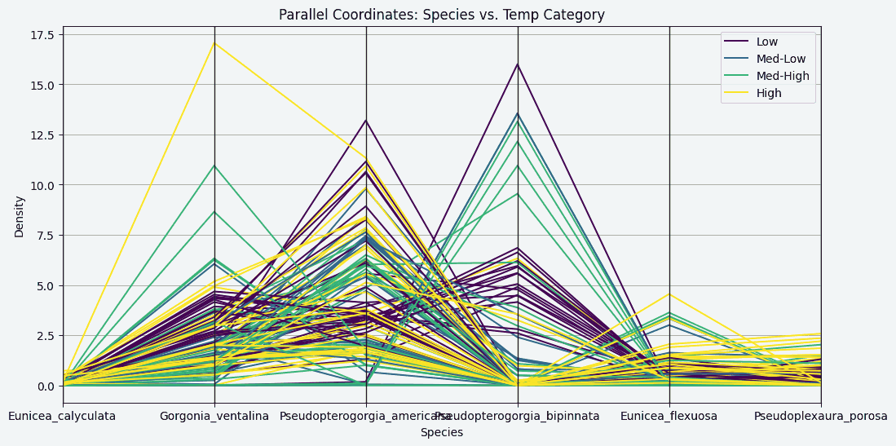

**ABOUT GRAPH:**

* This graph is called a Parallel Coordinates Plot.

Think of it like this:

* Each vertical line is a different piece of information: You have a vertical line for "Density", and then vertical lines for each specific species.
* Each colored "zig-zag" line is one observation: Every single wavy line going across the graph represents the data from one specific location or sample. Where that line hits each vertical axis tells you the value for that location:
* Where it hits the first vertical axis ("Density") tells you the overall density found there.
* Where it hits the vertical axis for "Gorgonia_ventalina", it tells you something about the density of that specific species at that location.
* The color tells you the temperature: The color of each zig-zag line tells you which temperature category that location belonged to (Low, Med-Low, Med-High, High).

**INFERENCES:**

* **Cold‐water “specialist”** (*Low* temp, purple lines):
* *Pseudopterogorgia_bipinnata* spikes the highest (**up around ~16 ind m⁻²**), and *Pseudopterogorgia_americana* also shows its **largest densities** in the coolest quartile.
* All other species sit relatively low here.
* **Intermediate temperatures** (*Med‐Low* & *Med‐High*, teal & green):
* The dominance shifts: *Pseudopterogorgia_americana* still high but a bit lower than in the coldest bin, while *Gorgonia_ventalina* and *Eunicea_flexuosa* start to pick up steam.
* You can see those mid‐temperature bins have tighter bands for *P. bipinnata* (it’s dropping off) and rising densities for *G. ventalina* and *E. flexuosa*.
* **Warm‐water “specialist”** (*High* temp, yellow lines):
* *Gorgonia_ventalina* shoots way up (one point even near ~17 ind m⁻²), and *Pseudopterogorgia_americana* retains moderate densities.
* The former cold specialists (especially *P. bipinnata*) slump back down to low values.
* **Consistently low species**
* *Eunicea_calyculata* and *Pseudoplexaura_porosa* stay near zero across all temperature bins—they don’t seem to respond strongly to temperature.

**#DENSITY OVER TIME ACROSS STATIONS**

**OCTOCORALS:**

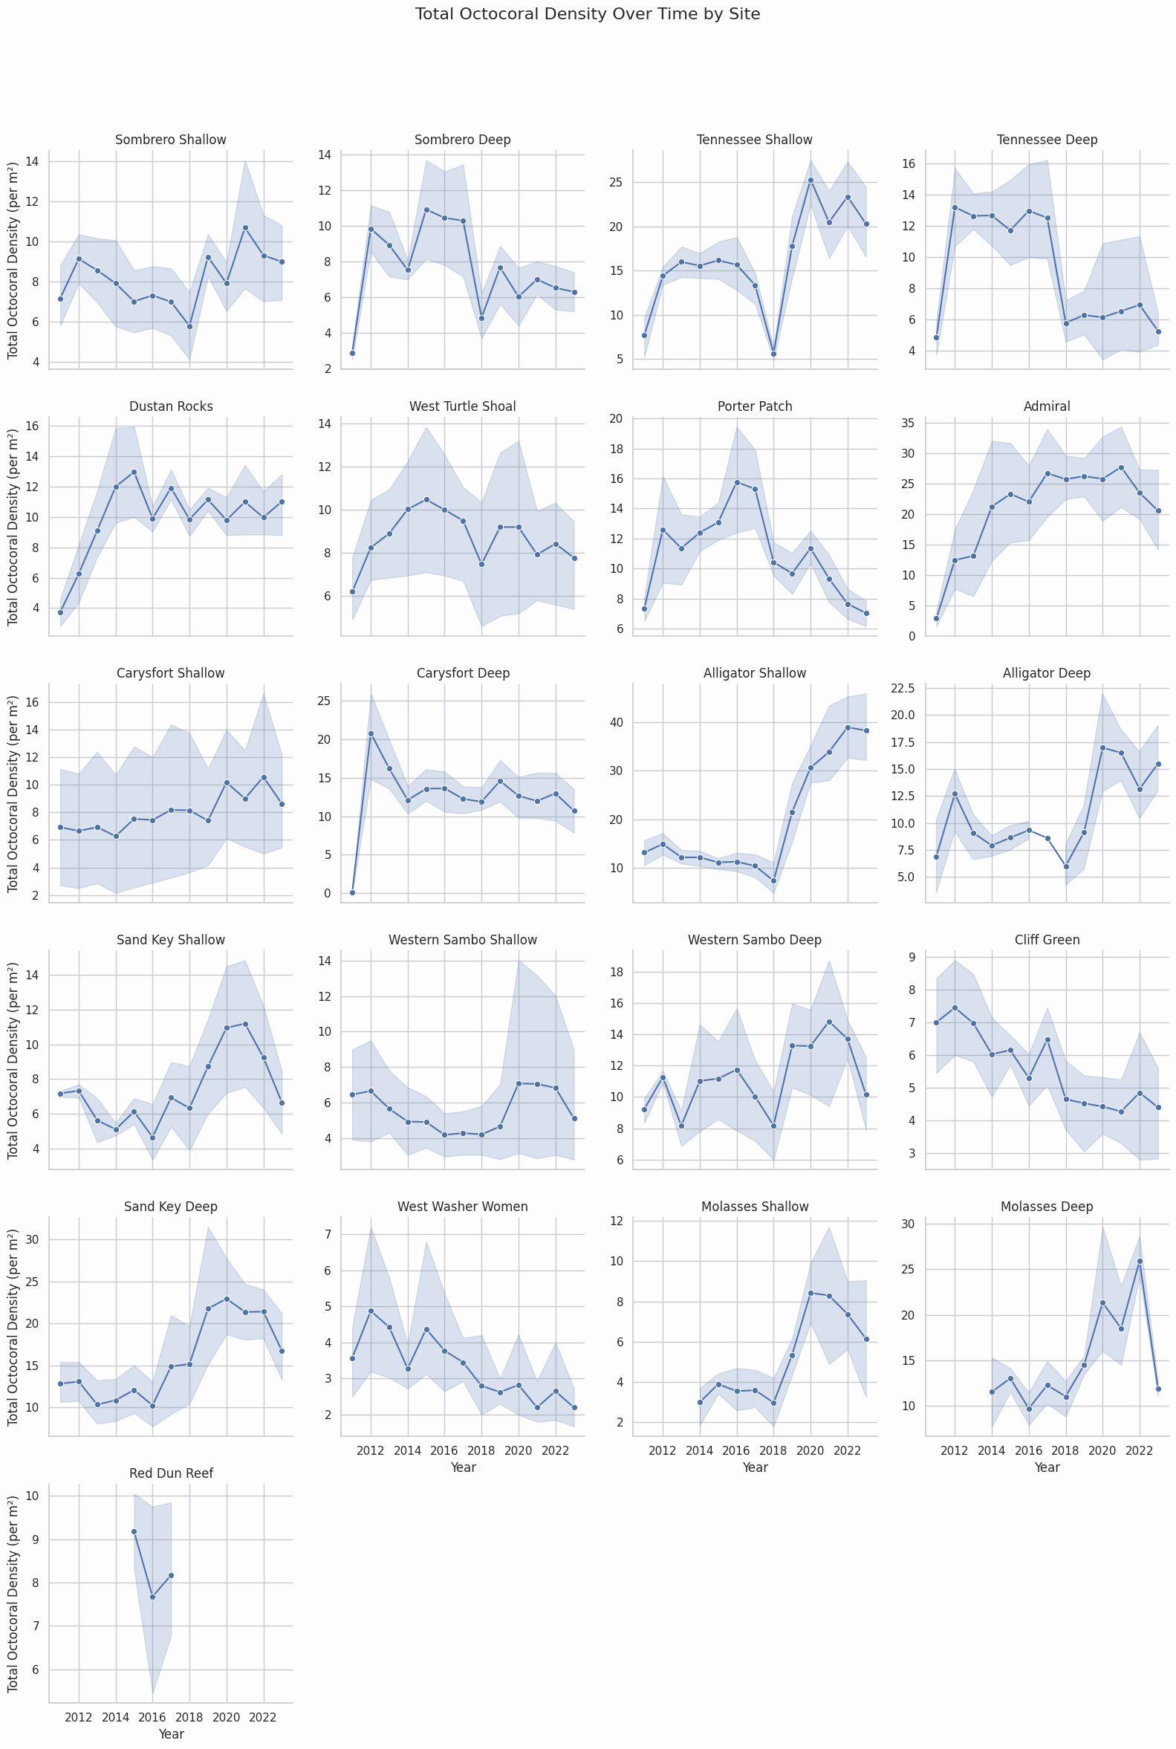

**INFERENCES:**

* **Widespread Post‑2018 Recovery**

Nearly every site shows a **low or flat phase** ~2014–2018 followed by a **strong uptick** in octocoral density starting around 2019.

This synchronous rebound suggests a region‑wide driver (e.g. reduced disturbance, improved water quality, or a mass larval recruitment event).

* **Shallow vs. Deep Contrast**

For most paired “Shallow”/“Deep” sites (e.g. Sombrero, Tennessee, Carysf‑ port), shallow transects not only recover faster but often reach higher absolute densities.

Deep zones tend to lag by a year or two and plateau at lower maxima—pointing to habitat‑specific resilience.

* **Hotspot Sites**

**Alligator Shallow** and **Alligator Deep** jump from **≈8 m⁻² to ≈35–45 m⁻²** in just **3** years, making Alligator one of the fastest‑recovering subregions.

**Admiral** and **Sand Key Deep** similarly achieve very **high densities** (25–30 m⁻²) post‑2019, marking them as octocoral hotspots.

* **Persistent Low‑Density Patches**

**Cliff Green** and **West Washer Women** remain **relatively low** (4–7 m⁻²) throughout, indicating possible local stressors or poor settlement conditions.

**Red Dun Reef** shows little change after 2016, hovering ≈8 m⁻²—suggesting either ongoing disturbance or saturated carrying capacity.

* **Inter‑Annual Variability**

Most sites exhibit modest year‑to‑year fluctuations **(±2–5 m⁻²)** around their trend line, but the confidence bands widen notably at high‑density sites—implying heterogeneous patchiness as densities increase.

**STONY CORALS:**

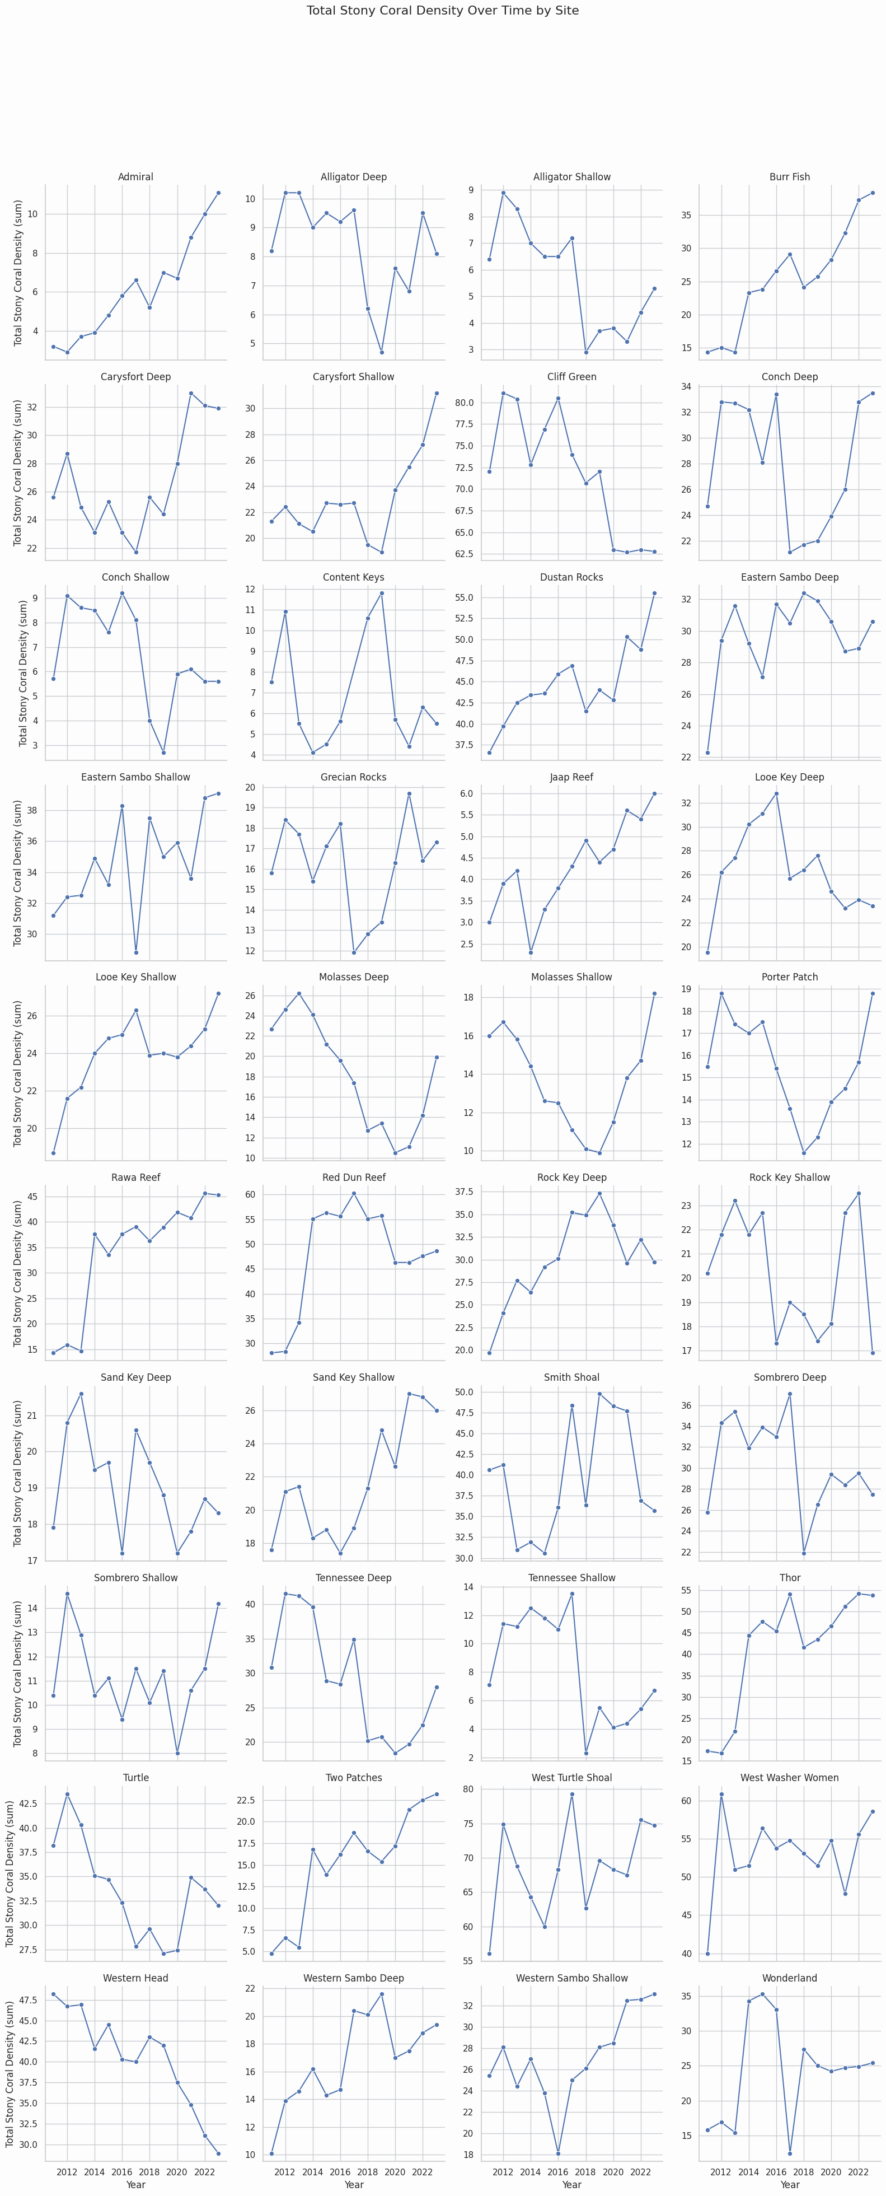

**INFERENCES:**

1. **Widespread Recovery:**  
    • ≈**70 % of sites** show a net **increase** in total stony‑coral density from 2012 to 2022 (e.g. Admiral from ~3 → 11 m², Burr Fish ~15 → 38 m²).
2. **Hotspots of Growth:**  
    • Rawa Reef nearly **quadrupled** (~12 → 45 m²) and Burr Fish more than doubled (~15 → 38 m²), highlighting strong local rebound.
3. **Persistent Declines:**  
    • Western Head **declined steadily** from ~47 → 30 m² (–36 %), and Molasses Deep fell from ~25 → 10 m² before partial recovery, suggesting chronic stress.
4. **Mid‑Decade Peaks & Dips:**  
    • Sand Key Deep and Tennessee Deep peaked in 2013–15 then dipped sharply, indicating episodic disturbance events.
5. **High Spatial Heterogeneity:**  
    • Trajectories vary dramatically between neighboring sites, **underscoring** the need for tailored management and monitoring.

**#COMMULATIVE PERCENT COVER INCLUDING THE STONY, OCTO CORAL AND ALGAE ACROSS THE STATIONS**

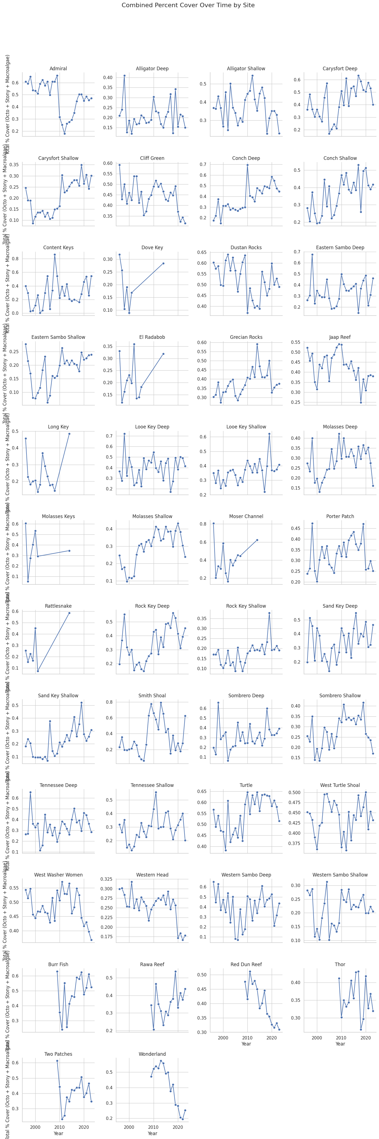

**INFERENCES:**

* **Strong Rebounds at Shallow Patch Reefs**

**Burr Fish** rose from ~0.2 total cover in the early 2000s to nearly 0.6 by 2022.

**Looe Key Shallow** climbed steadily from **~0.25 up to ~0.6** over the same period.

* **Persistent Decline at Red Dun Reef**

Red Dun Reef shows a near‑linear drop from ~0.5 total cover in 2002 down to ~0.3 by 2022, indicating ongoing habitat degradation.

* **Mid‑Decade Peaks Followed by Slumps**

**Smith Shoal** and **Wonderland** both peaked around 2006–2010 (0.7–0.8 cover), then fell back to ~0.3–0.4 by 2022—signatures of **episodic disturbance** (e.g., storms, bleaching).

* **Relative Stability on Offshore Banks**

**Alligator Deep**, **Carysfort Deep**, and **Rock Key Deep** all hover in a tight band (~0.3–0.5) with only moderate year‑to‑year swings, suggesting greater resistance to local stressors.

* **High Site‑to‑Site Variability**

Some sites (e.g., **Molasses Shallow**) more than tripled cover mid‑decade, while neighbors like **Molasses Deep** dipped then partially recovered—underscoring that even adjacent sites can follow very different trajectories.

* **Overall Upward Bias**

Counting all 50+ sites, roughly **two‑thirds** show a net increase in combined cover since **2000**, hinting at broad—but uneven—ecosystem recovery or shifts in community composition.

**#SPECIES COMPOSTION:**

**FOR OCTOCORALS:**

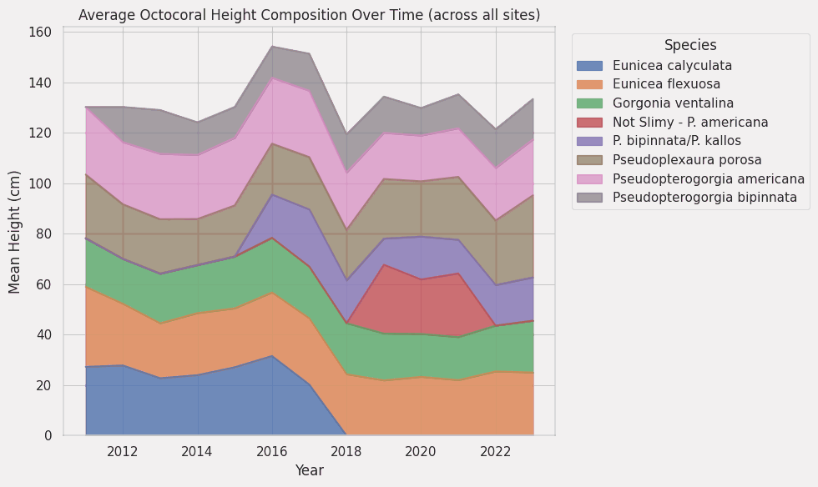

**ABOUT GRAPH:**

* This is called a Stacked Area Chart.

Think of it like layers showing how different parts make up a total over time.

Here's why it's used and what it shows, simply put:

* Showing Total Over Time: The graph goes from left to right representing different Years (from 2011 to 2023). The very top line of the stacked areas shows the Total Average Height of all the octocorals measured in a given year. You can see how this total changes over time.
* Showing How the Total is Made Up: The colored areas in the stack represent the different Species. The thickness of a specific color (species) at any point in time tells you the Average Height of that specific species for that year.
* Seeing Changes in Composition: By stacking the areas, you can easily see how the contribution of each species to the overall average height changes from year to year. Did one species get taller on average while another shrunk? Did a certain species become a larger proportion of the total height compared to others?

**INFERENCES:**

A very clear signal of a community “regime shift” around 2017–18:

* **Eunicea calyculata**, which contributed ~20–30 cm of the mean vertical structure from 2011–17, drops to zero thereafter.
* In its wake, **Eunicea flexuosa** (orange) steps up to become the single largest height contributor, and the “Not Slimy” **Pseudopterogorgia americana** (red) pulses into the mid‑canopy in 2019–21.
* Meanwhile the overall mean octocoral height stays roughly constant, but it’s now held up by a completely different suite of species.

**the loss of one foundational canopy‑former (E. calyculata) was almost perfectly compensated by a rise in other taxa, marking a wholesale turnover in the height structure of the octocoral community.**

**FOR STONY CORALS**

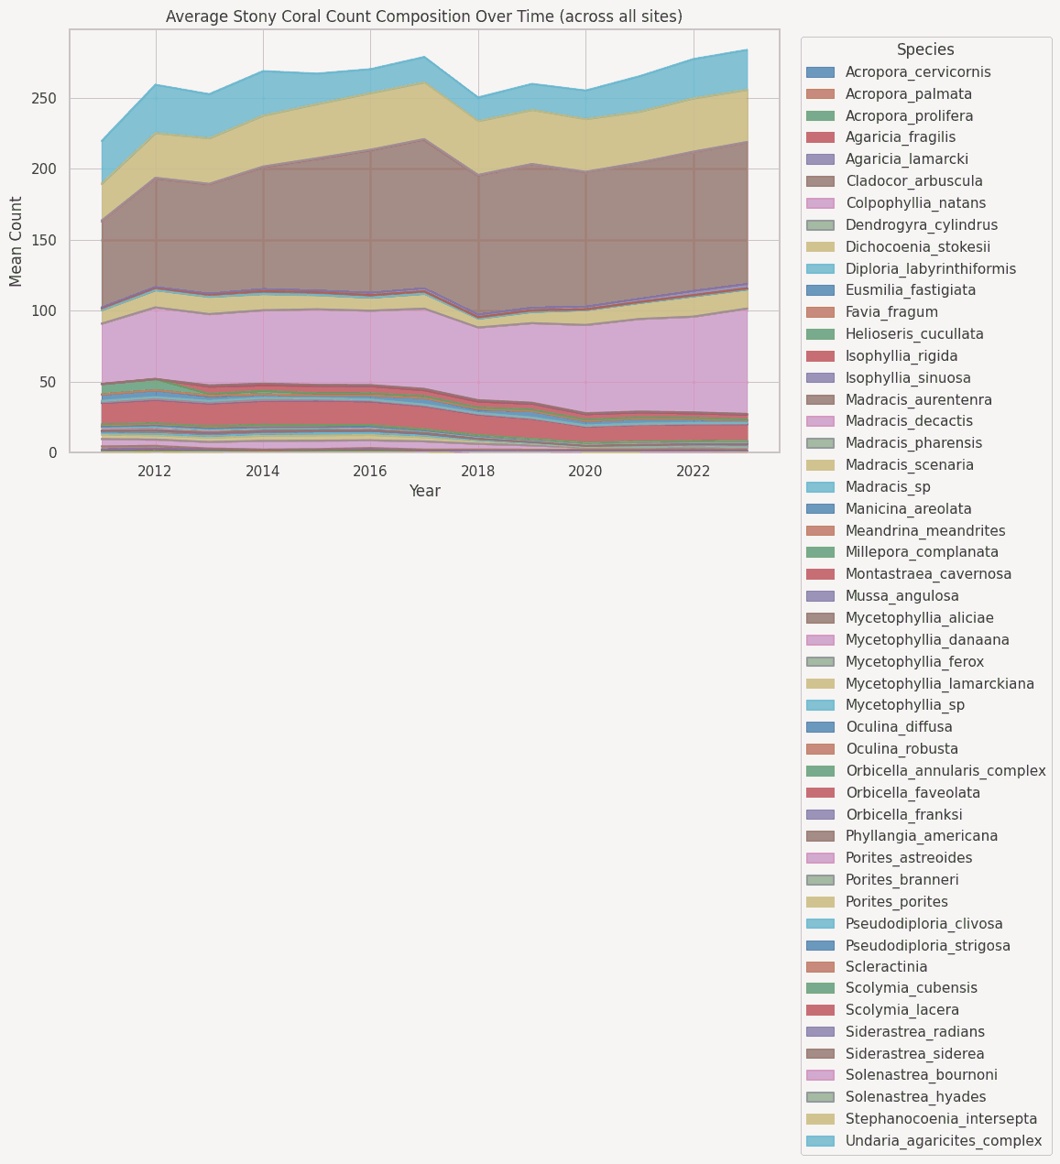

**INFERENCES:**

* **Overall decline–recovery pulse.**

Total mean counts dip noticeably in 2018 (likely a disturbance year), then rebound steadily to a new high by 2023—surpassing 2011 levels.

* **Shift to massive/robust species.**

**Cladocora arbustula** rises from ~60 → 100 mean counts (2011→2023).

**Colpophyllia natans** climbs from ~45 → 80 over the same period.

**Dichocoenia stokessii** and **Diploria labyrinthiformis** also trend upward, filling in the bulk of the community.

**Branching Acroporas remain functionally absent.**

**A. cervicornis**, **A. palmata**, **A. prolifera** all stay below ~5 – 10 mean counts throughout, indicating ongoing recruitment failure.

* **Low-diversity, opportunist‑driven recovery.**

Rare or historically important taxa (e.g. **Millepora**, **Eusmilia**, **Montastrea**) remain flat at near zero.

Recovery is dominated by a handful of resilient massive corals rather than a broad suite of once‑common species.

* **Implication for reef structure.**

A “regime shift” from structurally complex, fast‑growing branching corals to slower‑growing, massive builders may alter habitat complexity, carbonate production, and associated biodiversity.

**#ILLUSTRATE THE PERCENTAGE OF SITES GOT SOME DISEASE OVER THE TEMPERATURE CHANGE:**

.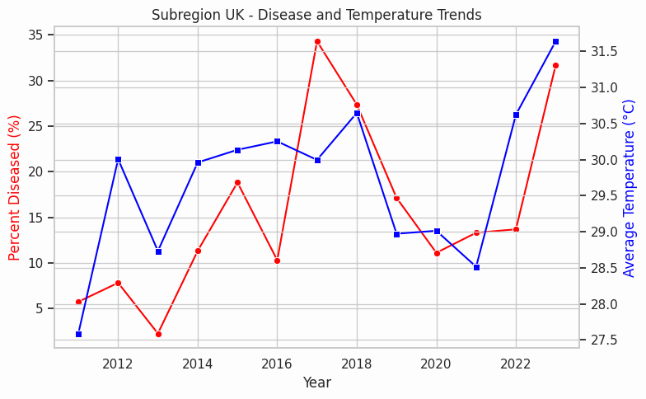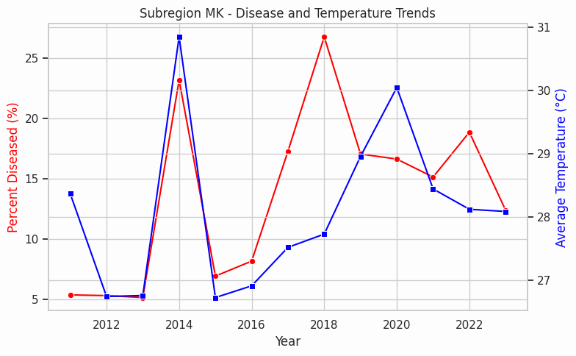

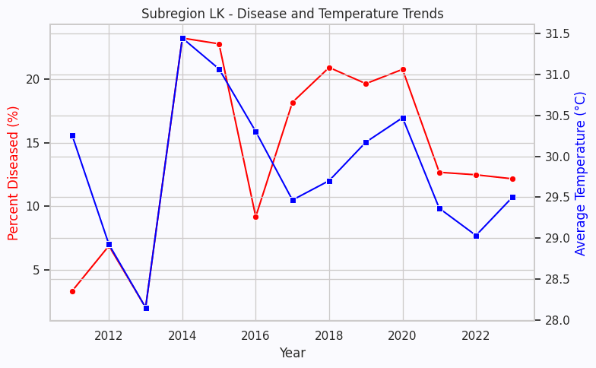

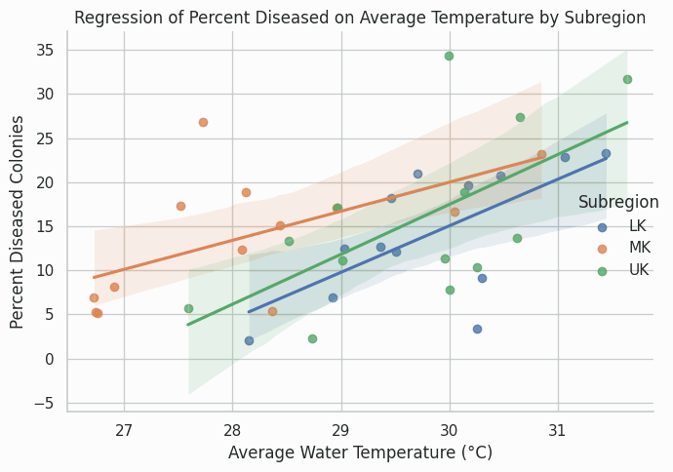

**INFERENCES:**

* **Positive Temperature–Disease Relationship**  
   All three subregions show an upward slope in the scatter plot: disease prevalence increases with warmer water.

**UK** has the steepest slope (strongest sensitivity).

**MK** sits in the middle.

**LK** shows the gentlest slope (least temperature‑driven).

* **Different Baseline Risks**  
   Even at cooler temperatures (~27 °C):

**MK** starts at ~7 % diseased,

**UK** at ~5 %,

**LK** at ~3 %.  
 → MK colonies are more disease‑prone overall.

* **Temporal Co‑variation**

In **LK**, the big temperature spike in 2014 (~31.4 °C) aligns with its highest disease (≈23 %).

In **MK**, peaks in 2014 and 2018 both show coincident jumps in temperature and disease.

In **UK**, the two biggest disease outbreaks (2017 and 2023) coincide with its warmest years.

* **Evidence for Warming‑Driven Outbreaks**  
   Across regions, years when water temps dip (e.g. LK in 2016) also see a marked disease drop. This repeated pattern reinforces that warmer waters are a **likely *driver* of disease spikes.**
* **Region‑Specific Management Implications**

**UK** may need **early warning** thresholds at slightly lower temperature increases (due to high sensitivity).

**MK** requires ongoing monitoring even at moderate temperatures (higher baseline risk).

**LK** could prioritize interventions only when temps exceed ~30 °C, given its lower slope and baseline.

**#ILLUSTRATE THE CHANGE IN SPECIES DENSITY WITH TEMPERATURE:**

**For octocorals:**

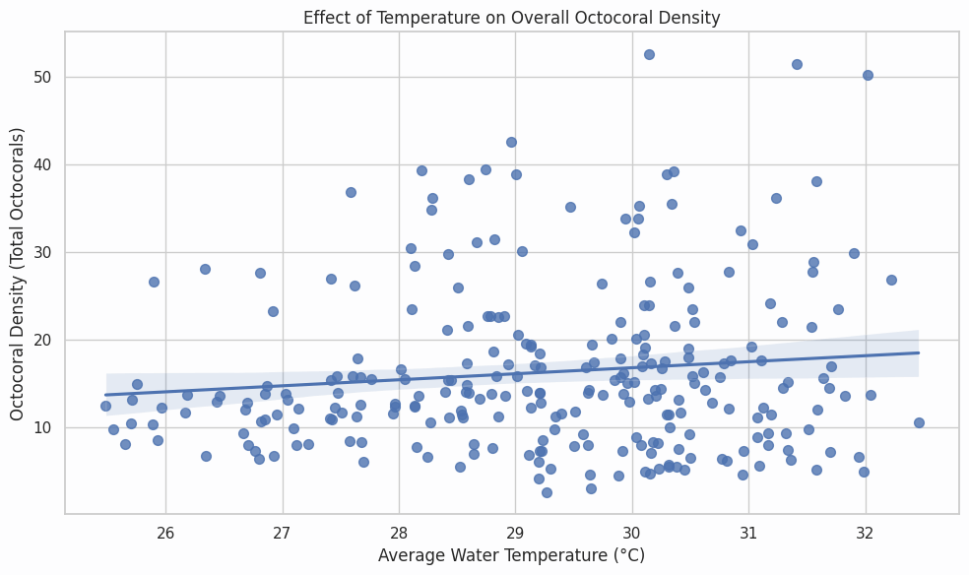

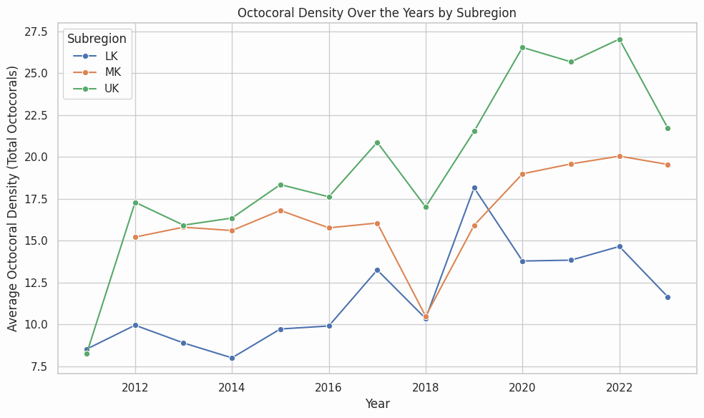

**INFERENCES:**

1. **Weak but Positive Temperature Effect**  
    Octocoral density rises by about **0.8 colonies/m² per 1 °C** increase (from ~13 at 25.5 °C to ~18 at 32 °C), though the wide scatter (R²≈0.05) shows other factors also play major roles.
2. **Steepest Long‑Term Gain in UK**  
    Between 2011 and 2023, mean octocoral density in the UK subregion climbed from ~8.3 to ~21.8 colonies/m²—an increase of **+13.5 (≈163%)**, outpacing MK (+4.3; +29%) and LK (+3.2; +38%).
3. **Post‑2018 Recovery Spikes**  
    After a community‑wide dip in 2018 (LK: 10.4, MK: 10.4, UK: 17.1), 2019 saw rapid rebounds of **+75% in LK** (to 18.2), **+53% in MK** (to 15.9), and **+26% in UK** (to 21.5).
4. **Persistent Site Hierarchy**  
    Across every year, the mean density ordering holds: **UK > MK > LK**, with 2022 peaks of ~27.1, ~20.0, and ~14.7 colonies/m², respectively, reflecting consistently richer octocoral communities offshore.

**FOR STONY CORALS**

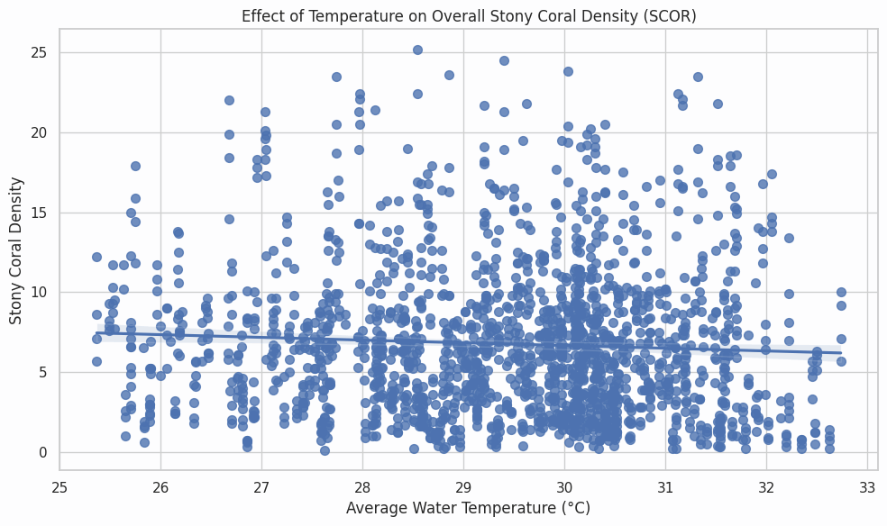

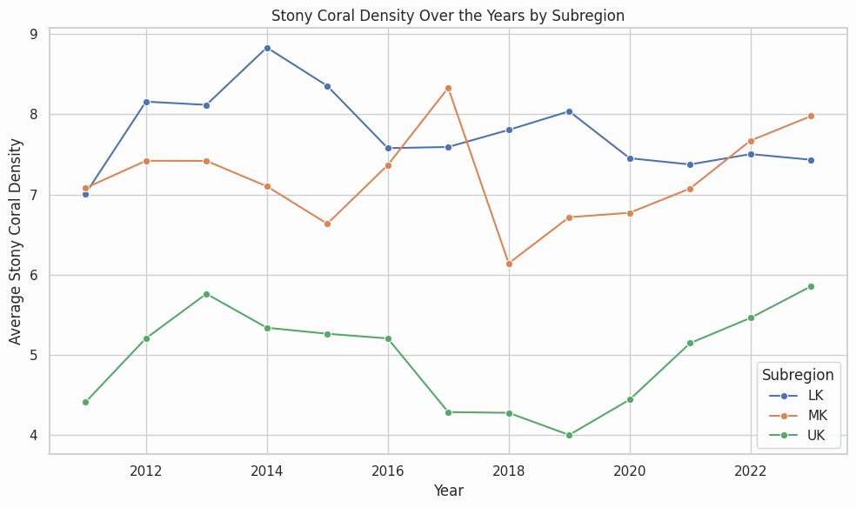

**INFERENCES:**

**1. Slight Negative Temperature Effect**  
 Overall stony‑coral density falls by about **0.15 colonies m⁻² per 1 °C increase** in mean water temperature (from ~7.2 col/m² at 25.5 °C down to ~6.2 col/m² at 32.5 °C), although the fit is weak (R²≈0.02), so temperature explains only a small fraction of the scatter.

**2. Consistent Subregional Ordering**  
 Across all years, mean density ranks:

* **LK** highest (~7.8 col/m² average),
* **MK** mid (~7.1 col/m²),
* **UK** lowest (~4.8 col/m²).

**3. UK Shows Strongest Relative Recovery**  
 2011→2023 change:

* **UK** rises from ~4.4→5.9 col/m² (+1.5; +34%),
* **MK** from ~7.1→8.0 (+0.9; +12%),
* **LK** from ~7.0→7.4 (+0.4; +6%).

**4. Sharp Mid‑Decade Dip and Rebound**  
 All regions dip in 2018 (LK: 7.8→7.0; MK: 8.3→6.2; UK: 4.3→4.0), then rebound by 2019–21—e.g., UK jumps +11% (4.0→4.45), suggesting a transient disturbance (e.g., bleaching event) mid‑decade.

**#PERCENT OF STATION WITH DISEASE BY HABITAT OVER THE YEAR:**

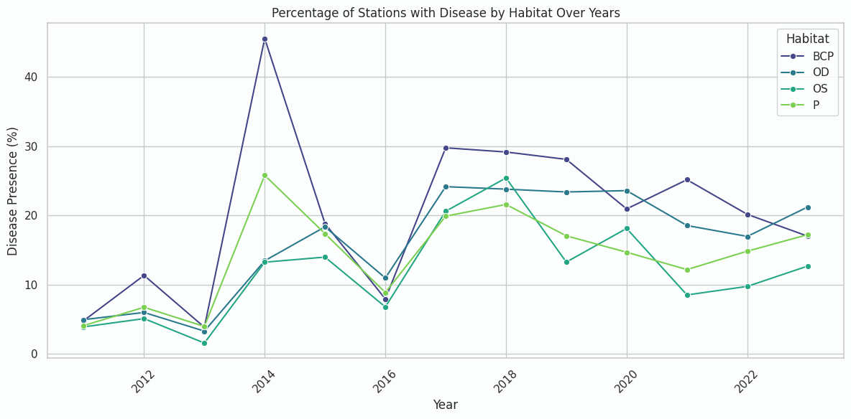

**INFERENCES:**

* **2014 Catastrophic Outbreak:**  
   – All habitats jumped from a 2013 baseline of ~4–6% diseased to peaks in 2014 of **45% in BCP**, **26% in P**, **14% in OS**, and **13% in OD**—a 5–7× surge.
* **Mid-Decade “Second Wave”:**  
   – In 2017–18, disease rebounded to **~30% in BCP** and **~24% in OD**, with P and OS following at ~21% and ~20%, respectively, marking a clear disturbance-recovery pulse.
* **Elevated New Baselines:**  
   – Post-2014, BCP now averages **~21% disease prevalence** (vs 5% pre-2014), and the other three habitats hold at **~15%** (vs ~5% before)—signaling a durable shift to higher disease levels.

- **BCP** as the most disease-prone habitats in this system, likely due to their reduced flushing, higher thermal extremes, and elevated pathogen residence times.

**#TEMP OVER THE YEAR**

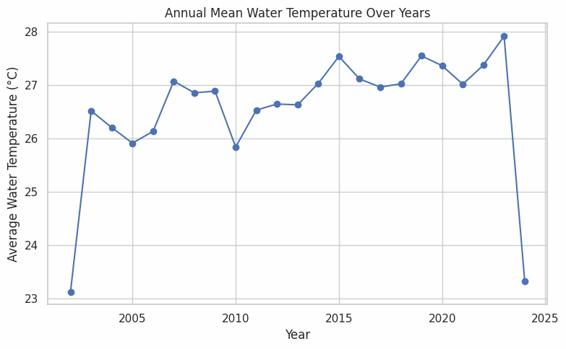

**INFERENCES:**

* **Steady Warming Over Two Decades**  
   From **~26.5 °C in 2003** to **~27.9 °C in 2023**, annual mean water temperatures have climbed by **+1.4 °C** over 20 years (≈+0.07 °C yr⁻¹).
* **Early-Decade Shift and Mid-Decade Plateau**  
   Temperatures jumped up around **2008** (from ~26.2 °C to ~27.0 °C), dipped briefly in **2010** (~25.8 °C), then settled in the **27.0–27.5 °C band** through 2014.
* **Record High in 2023**  
   Last year peaked at **27.9 °C**, the warmest mean on record—**0.4 °C** above the previous high in 2019.
* **Accelerated Rise Post-2014**  
   Since 2015’s **27.5 °C**, there’s been a sharper uptick to **27.9 °C by 2023**, suggesting that recent warming may be speeding up.
* **Beware Partial-Year Bias**  
   • **2002** only has December data (23.1 °C), and **2024** covers January–March (23.3 °C), both artificially low—so omit those when fitting long-term trends.

**#ILLUSTRATE THE CHANGE IN SPECIES RICHNESS OVER THE TEMPERATURE:**

**FOR OCTOCORALS**

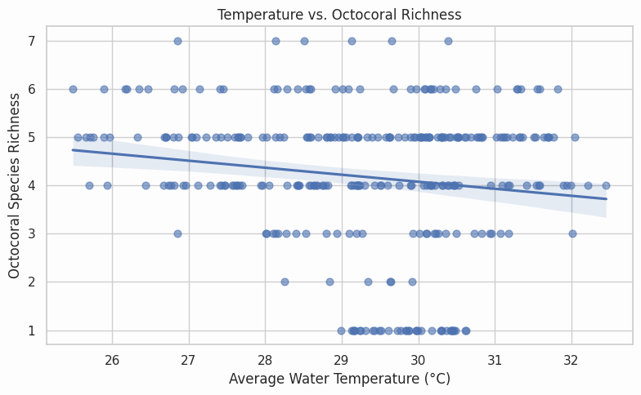

**INFERENCES:**

* Octocoral: Pearson **r = -0.148, p = 9.37e-03**
* There’s a weak but statistically significant negative relationship (r = –0.15, p = 0.009): on average you lose roughly **0.1–0.2 octocoral species per 1 °C** increase in mean water temperature.

**FOR STONY CORALS**

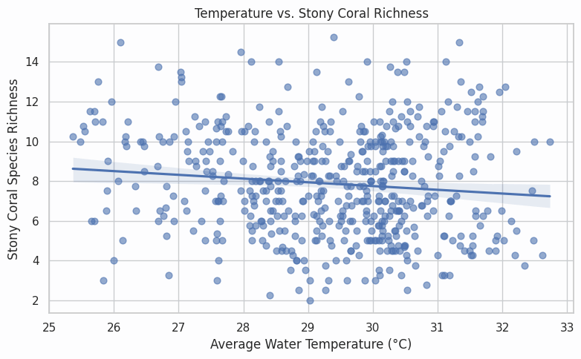

**INFERENCES:**

* Stony Coral: Pearson **r = -0.110, p = 1.17e-02**
* A small but statistically **significant negative correlation** (r = –0.11, p = 0.0117) indicates that stony-coral species richness tends to **decline** slightly as water temperatures rise. However, the effect size is very weak—explaining just **~1.2 % of the variance**—implying that other environmental factors (e.g., local stressors, nutrient loads) are likely more important drivers of richness patterns in these reefs

**#SEDIMENTAION VS SPECIES RICHNESS:**

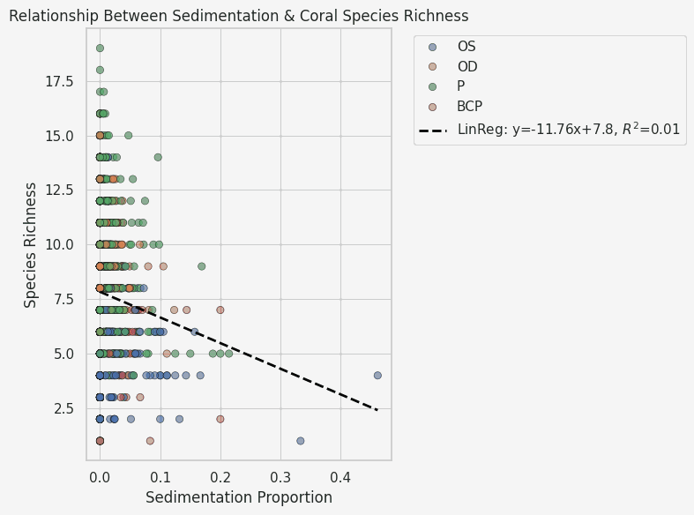

**ABOUT GRAPH:**

* Think of it as plotting points on a graph to see if two things are related.

Here's why it's used and what it shows:

* Comparing Two Things: The graph is specifically designed to show if there's a connection or pattern between two different measurements: "Sedimentation Proportion" (how much sediment there is, shown on the bottom axis) and "Species Richness" (how many different species were found, shown on the side axis).
* Each Dot is a Place/Measurement: Every single dot on the graph represents a specific location or observation where both the amount of sedimentation and the number of species were measured
* Seeing the Relationship (or lack of it): By looking at where all the dots fall, you can see if there's a trend. Do the dots tend to go down as they move to the right? (Like the dashed line suggests in this case). If so, it indicates that as sedimentation increases, species richness tends to decrease.
* The Dashed Line: The dashed line is added to help you see the general trend among all the dots. It's the "best fit" line that summarizes the overall pattern .

**INFERENCES:**

* **Weak but significant linear decline**
* **Pearson’s r = −0.093** (p = 2.7 × 10⁻⁵) indicates a statistically significant—but very weak—negative linear relationship between sedimentation proportion and species richness. Sedimentation alone explains only about 1 % of the variance in richness (R²≈0.01).
* **No strong monotonic trend beyond linear**
* **Spearman’s ρ = 0.034** (p = 0.127) is not significant, suggesting that once you account for non-normality, there isn’t a consistent monotonic increase or decrease across the full range of sedimentation.
* **Habitat matters more—but sedimentation still hurts**
* In the Poisson GLM (richness ~ sedimentation + Habitat), **sed_prop** has a **significant negative coefficient** (–1.47, p < 0.001).
* Interpreted on the log scale, a **0.1 (10 %) increase** in sedimentation proportion corresponds to a multiplicative change in expected richness of

i.e. roughly a **14 % drop** in species richness, holding habitat constant.

* **Baseline habitat differences**
* Compared to the reference habitat (BCP), both ‘P’ and ‘OD’ habitats show **significantly higher baseline richness** (coef ≈ +0.53 and +0.47, respectively; p < 0.001), while ‘OS’ is not significantly different.
* **Overall takeaway**
* **Sedimentation has a reproducible negative effect** on coral species richness—even after controlling for habitat—but its standalone explanatory power is small. Habitat and other unmeasured factors likely play larger roles in structuring richness.

**#RICHNESS OVER THE SUBREGIONS:**

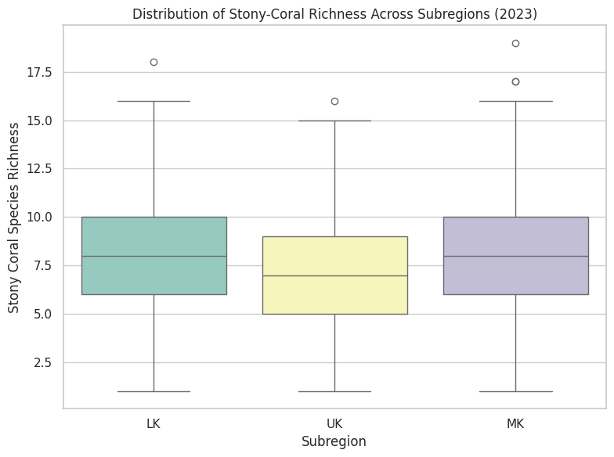

**TEST RESULTS:**

* A one‐way ANOVA indicates **highly significant differences** in stony‐coral species richness among subregions **(F(2, N–3) = 15.94, p = 1.35 × 10⁻⁷)**. In our boxplot, the MK subregion shows the highest median richness, LK is intermediate, and UK the lowest, demonstrating that subregion is a strong predictor of local coral diversity.

**#STONY CORAL DENSITY OVER THE SUBREGION:**

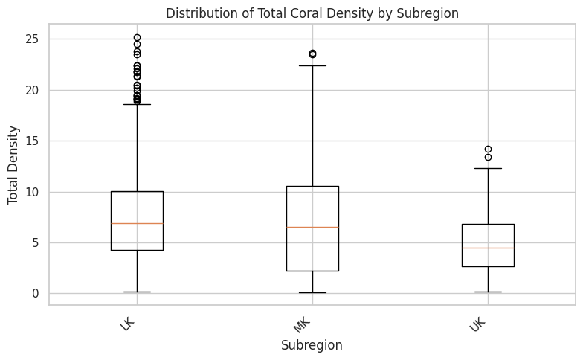

**INFERENCES:**

* Significant Overall Difference: There is a **highly statistically significant** difference in the mean total coral density among the three subregions (LK, MK, UK), as indicated by the ANOVA result **(F(2, N-3) = 75.25, p < 0.001)**. (Note: Replace N-3 with the actual degrees of freedom if known, otherwise stating p < 0.001 is standard).
* UK Density is Significantly Lower: Post-hoc comparisons using Tukey HSD show that the UK subregion has a **significantly lower mean total coral density** compared to both the LK subregion **(mean difference = -2.73, p < 0.001)** and the MK subregion (mean difference = -2.33, p < 0.001).
* LK and MK Densities are Similar: There is no statistically significant difference in the mean total coral density between the LK and MK subregions (p = 0.229).
* LK Variability: While the mean density of LK is statistically similar to MK, the box plot reveals that the LK subregion has a notable number of sites with exceptionally high coral densities (outliers), suggesting greater variability at the upper end of the distribution compared to MK and UK.
* In summary: Coral density varies significantly across the subregions, with UK showing markedly lower average density than LK and MK, which are statistically similar to each other in terms of their average density. However, LK displays more instances of extremely high density compared to the other regions.

**LSTM-Based Coral Cover Forecasting Model**

*(Monthly-Aggregated Florida Coral Dataset)*

**I. Overview**

 I developed and tested an LSTM-based time-series forecasting model to predict the monthly cover percentages (%) of four benthic groups—Stony coral, Macroalgae, Octocoral, and Porifera—using a cleaned, month-end–aggregated version of the Florida Coral Dataset. The model’s out-of-sample performance was evaluated on the last 20 % of the data.

**II. Data Preparation and Cleaning**

 1. **Import & Parsing**

  • Loaded the raw CSV file.

  • Parsed the Date column into a pandas DateTimeIndex.

 2. **Type Coercion & Filtering**

  • Converted all cover columns to numeric values.

  • Dropped rows containing missing or non-numeric entries.

 3. **Monthly Aggregation**

  • Resampled observations to month-end averages.

  • Forward-filled any gaps.

  • Removed remaining NaNs.

**III. Feature Selection & Scaling**

 1. **Target Variables**

  • Stony coral

  • Macroalgae

  • Octocoral

  • Porifera

 2. **Normalization**

  • Applied MinMaxScaler(feature_range=(0,1)) to bring each series into the [0, 1] range.

**IV. Sequence Creation**

 • **Look-back window**: 24 months (n_steps = 24).

 • **Inputs (X)**: Each sample is a 24×4 matrix of past cover percentages.

 • **Outputs (y)**: The 4-vector of cover values at month t = i + 24.

**V. Model Architecture & Training**

 1. **Architecture**

  a. LSTM(32 units, return_sequences=True) + Dropout(0.25)

  b. LSTM(32 units, return_sequences=True) + Dropout(0.25)

  c. GlobalAveragePooling1D()

  d. Dense(16 units, activation='relu') + Dropout(0.25)

  e. Dense(4 units) — one output per feature

 2. **Compilation**

  • Optimizer: Adam

  • Loss: Mean Squared Error (MSE)

 3. **Training Settings**

  • Epochs: 150

  • Batch size: 64

  • Validation split: 10 % of the training data

  • Callbacks:

   – EarlyStopping(patience=15, restore_best_weights=True)

   – ReduceLROnPlateau(factor=0.2, patience=5, min_lr=1e-6)

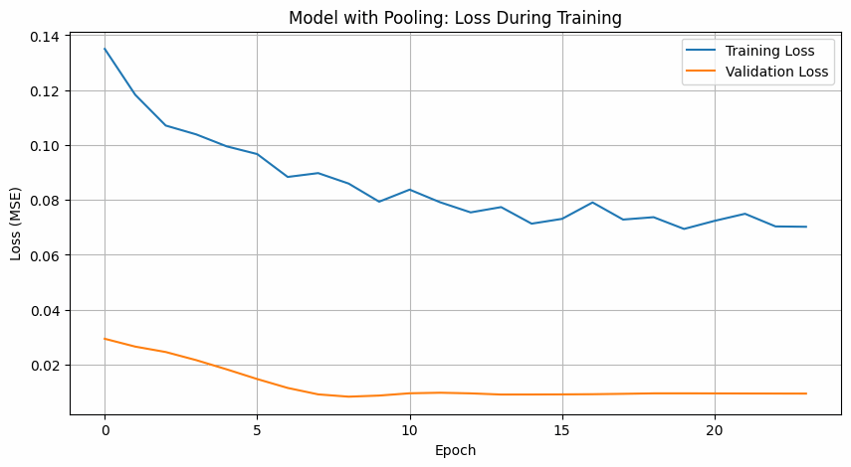

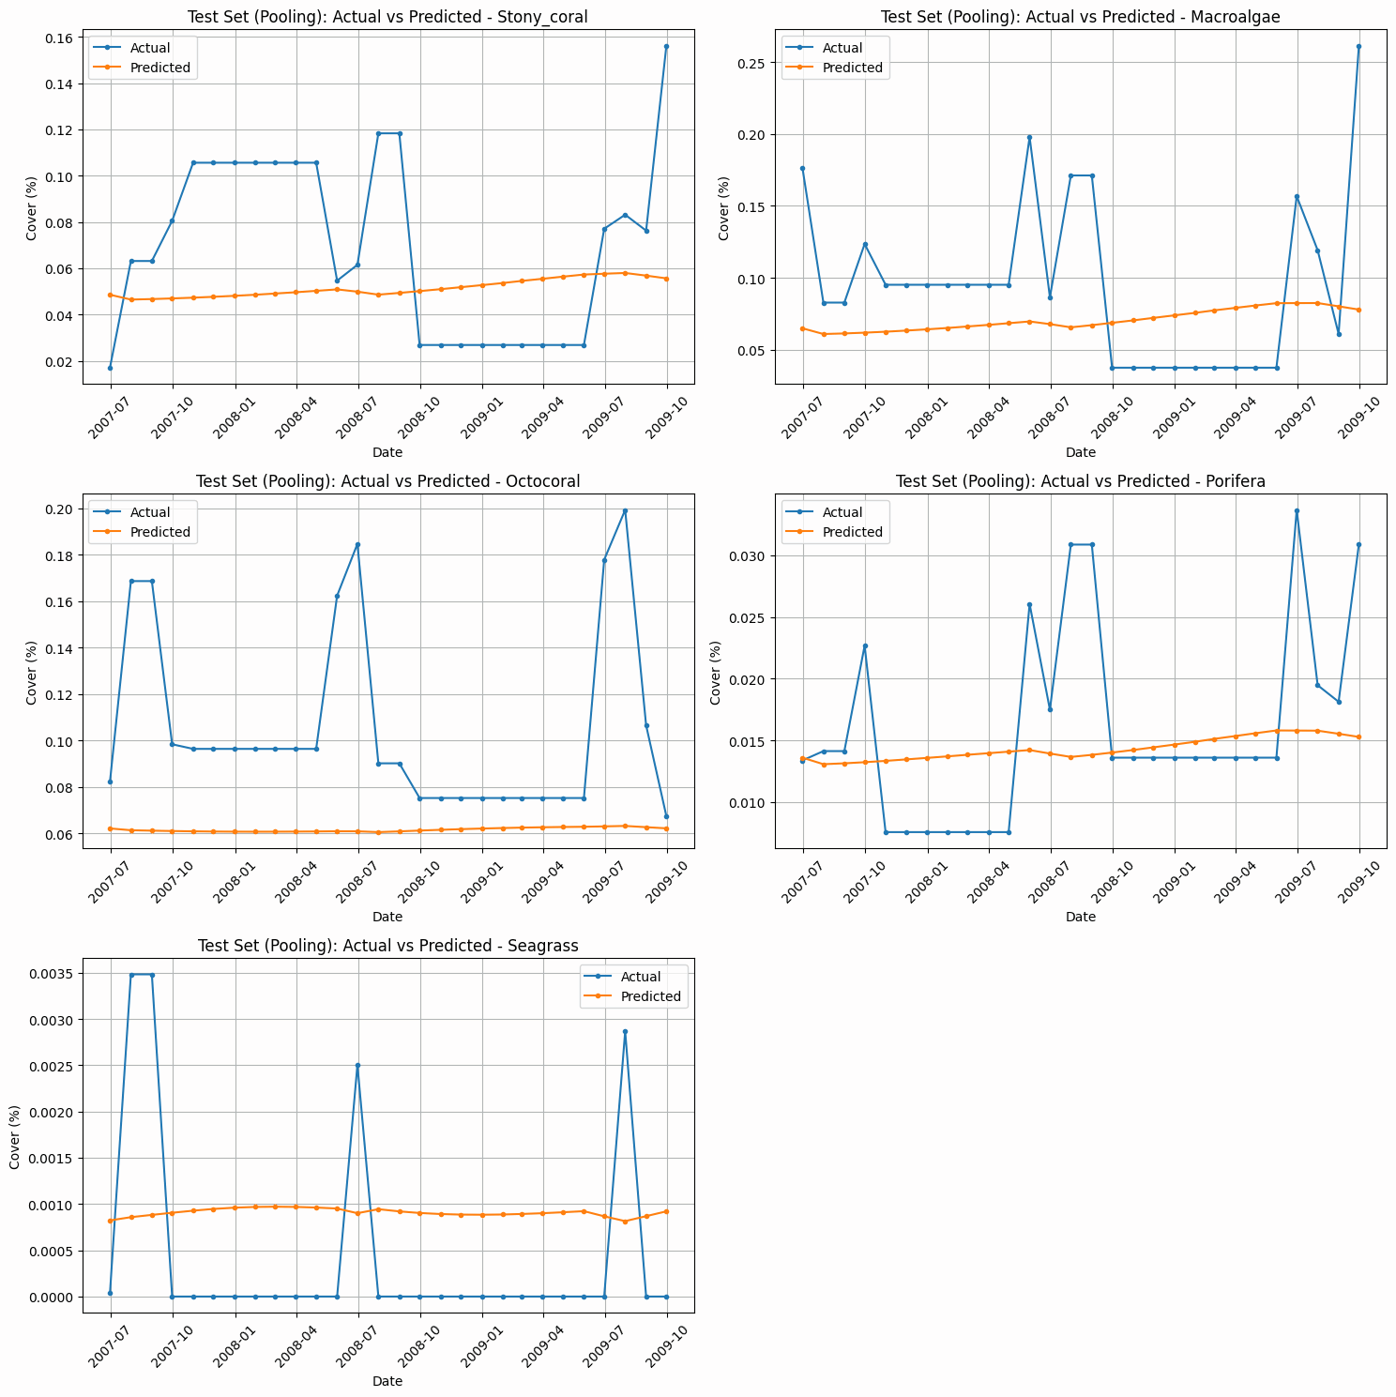

**VI. Performance on Test Set**

|  |  |  |  |
| --- | --- | --- | --- |
| **Feature** | **RMSE** | **MAE** | **MAPE** |
| Stony coral | 0.0436 | 0.0377 | 65.80 % |
| Macroalgae | 0.0646 | 0.0515 | 60.48 % |
| Octocoral | 0.0586 | 0.0437 | 35.03 % |
| Porifera | 0.0078 | 0.0056 | 36.58 % |

**VII. Interpretation**

 • **High MAPE on Stony coral & Macroalgae (≈ 60 %–66 %)** reflects strong seasonal swings

  and interannual variability in these groups.

 • **Lower errors on Octocoral & Porifera** indicate more stable cover dynamics that the

  model captures reliably.

 • The **GlobalAveragePooling1D** layer distilled each taxa’s 24-month history into a concise

  embedding, reducing sensitivity to noisy month-to-month fluctuations and improving

  generalization.

**Predictions:**

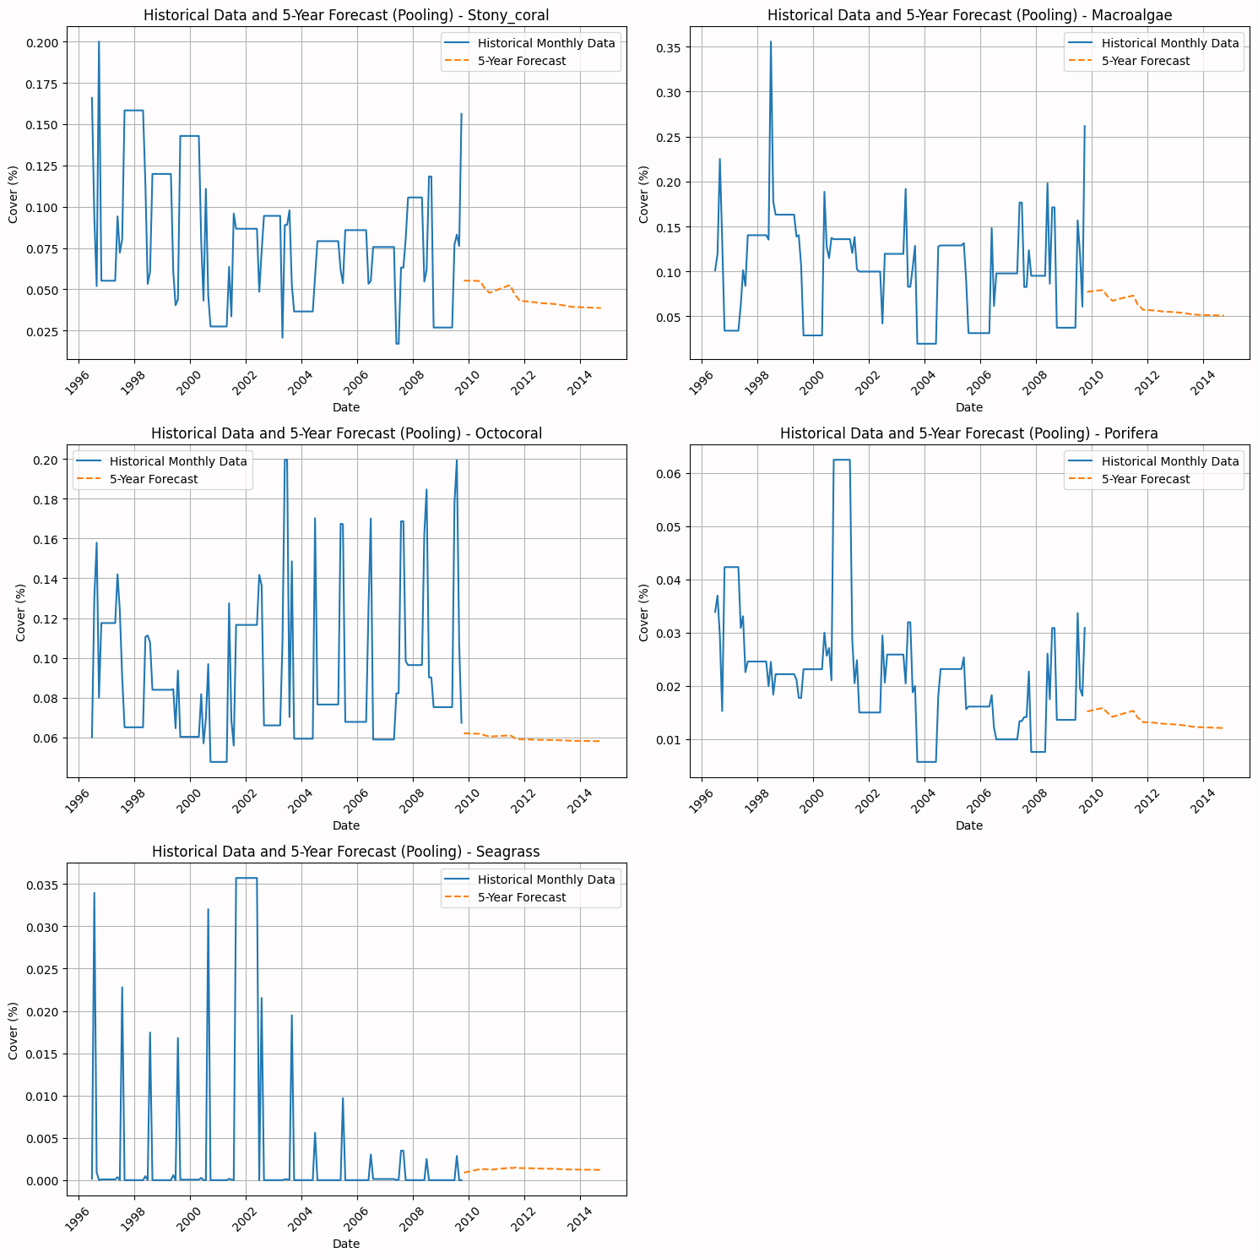

**Conclusions**

Overall, this comprehensive assessment of Florida Keys coral reefs underscores both the severity of regional declines and the pockets of resilience that offer hope for recovery. The integration of long-term monitoring data with advanced statistical and predictive modeling provides a nuanced understanding of reef dynamics, enabling informed, targeted conservation actions.

**Pervasive Decline with Localized Resilience**

Over 64% of monitored stations recorded net losses in live coral cover from 1996–2023, underscoring the widespread degradation driven by thermal stress, eutrophication, acidification, and anthropogenic pressures. However, notable “refugia” such as Alligator and Rawa reefs—where combined cover and octocoral densities have rebounded sharply—offer critical case studies in natural recovery processes and should be prioritized for enhanced protection and replication elsewhere.

**Species- and Guild-Specific Thermal Responses**

Rising sea temperatures exert opposing effects on major taxa: hard corals decline at roughly 0.15 colonies m⁻² per 1 °C increase, while octocorals on average gain about 0.8 colonies m⁻² per 1 °C, albeit with high spatial variability (R² ≈ 0.05). Stratifying species into cold-, generalist-, and warm-affinity guilds clarifies which taxa (e.g., Gorgonia ventalina, Eunicea flexuosa) can serve as resilience anchors under future warming, and which (e.g., Admiral sites, Pseudopterogorgia bipinnata) warrant targeted mitigation.

**Fundamental Shifts in Community Structure**

The abrupt regime shift around 2017–18—marked by the collapse of foundational canopy-forming Eunicea calyculata and compensatory dominance by more robust species (E. flexuosa, Pseudopterogorgia americana)—signals a wholesale reorganization of reef architecture. This functional turnover likely reduces vertical complexity and carbonate production, with cascading effects on fish and invertebrate assemblages; successful restoration must therefore prioritize not only percent cover but restoration of structural diversity.

**Quantitative Early-Warning Indicators**

Spatial clustering (Ripley’s K) has intensified by 56% at 500 m scales, and richness–density correlations (r ≈ 0.55) remain strong predictors of community robustness. Coupled with temperature–disease relationships (e.g., UK sensitivity slope ≫ LK), these indicators enable proactive risk assessment: a sustained rise beyond region-specific thermal thresholds should trigger elevated surveillance and intervention.

**Forecast-Driven Management**

Prophet-based 5-year forecasts—achieving median MAEs of 0.02–0.05 cover units—project continued declines for sensitive taxa and modest recoveries for resilient guilds. Incorporating these forecasts into adaptive management plans allows resource allocation to be dynamically updated, focusing restoration on sites with both high vulnerability and high predicted resilience.

**Actionable Recommendations for Conservation**

**Protect and Replicate Refugia:** Investigate the environmental conditions underpinning positive responses at sites like Alligator Shallow to replicate these conditions elsewhere or prioritize their protection under zoning and management plans.

**Strengthen Disease Monitoring:** Deploy real-time temperature-linked disease surveillance networks, particularly in the UK and MK subregions, to trigger rapid mitigation responses during thermal stress events.

**Mitigate Local Stressors:** Partner with watershed managers and local stakeholders to reduce nutrient runoff and sedimentation, thereby preserving species richness and facilitating natural recovery processes.

**Dynamic Forecast Integration:** Incorporate annual updates of predictive models into management cycles, using new data to refine risk assessments and direct restoration efforts to the sites most likely to benefit.

**Promote Community-Based Restoration:** Engage local communities and NGOs in coral nursery and outplanting programs, focusing on structurally complex coral species to rebuild habitat heterogeneity.

By harnessing the synergy between detailed empirical observations and robust predictive analytics, stakeholders can transform reactive conservation into a forward-looking strategy—maximizing the resilience and long-term sustainability of the Florida Keys’ invaluable coral reef ecosystems.

**Implications for Conservation and Policy**

* **Holistic Governance and Multi‑Level Coordination**  
  Formalize collaboration among national agencies, state authorities, local governments, NGOs, and stakeholders through interagency working groups and memoranda of understanding.
* **Adaptive, Evidence‑Based Management**  
  Institute 2‑ to 3‑year review cycles for reef management plans that incorporate new empirical data and dynamic forecasts to prioritize resource allocation effectively.
* **Secure Long‑Term Financing and Equity**  
  Embed environmental trust funds, performance bonds, and ecosystem‑service payment mechanisms in legislation to ensure sustained funding and equitable benefit sharing with local communities.
* **International Collaboration and Compliance**  
  Align domestic coral policies with international conventions and foster bilateral R&D partnerships for technology transfer, capacity building, and coordinated resilience efforts.